CLOUD COMPUTING AND BIG DATA

ASSIGNMENT 2

CO2: Analyze virtualization architectures to identify performance and security issues in cloud computing environments.

Assignment Title: Analyse, Evaluate and Validate a Virtualization Architecture for a Multi-Tenant University Private Cloud (Total Marks: 50)

Duration: 1 week

Scenario: EduCloud Virtualization Platform

A university runs a private cloud, EduCloud,in its data centre. EduCloud currently consists of:

• 16 physical hosts, each with 64 CPU cores, 512 GB RAM, NVMe SSD

storage and 2 × 25 Gbps NICs

• About 400 virtual machines (VMs) running the Student Information

System (SIS), the Learning Management System (LMS), the examination

portal, and departmental research workloads

• A shared storage backend and a software-defined virtual network

During semester registration week, users report slow response times and failed

logins.

You are the cloud architect. You must investigate, model, measure and compare

virtualization architectures for EduCloud, identify their performance bottlenecks and

security weaknesses, and recommend a design that remains practical as the

platform grows.

Design Challenge:

The university now plans to host external research collaborators&#39; big-data

workloads (Spark/Hadoop clusters) on the same infrastructure as the SIS. Re-

evaluate your design under these new multi-tenant conditions.
TASK 1 - Characterise the Virtualization Architectures (5 marks)

1.1 Selection and why the three are meaningfully different
Table 4. The three selected approaches.
 | A - Type-1 hardware-assisted VM | B - OS-level containers | C - Sandboxed container runtime
Category (from the brief) | Type-1 hypervisor, full virtualization (hardware-assisted) with paravirtual virtio I/O | OS-level virtualization | Sandboxed container runtime
Concrete stack | KVM + QEMU + libvirt (or Xen/ESXi) | Docker/containerd + runc | gVisor (runsc) under containerd, KVM platform
Kernel per tenant? | Yes - full guest kernel | No - one shared host kernel | Yes, but a user-space re-implementation (Sentry)
Isolation enforced by | CPU hardware (VT-x/EPT) + IOMMU, mediated by KVM | Namespaces + cgroups + seccomp (software in host kernel) | Sentry (memory-safe user-space kernel) + seccomp on host + KVM/ptrace boundary
VM-based / container-based | VM-based | Container-based | Container-based (VM-assisted)

They are architecturally distinct because the component that enforces isolation is different in each case: hardware virtualization extensions (A), the shared kernel itself (B), and a separate user-space kernel (C). They are not two configurations of one hypervisor. I deliberately did not choose Kata Containers/Firecracker as the third approach because they run on the same KVM hypervisor as A and would count as a configuration of it; they are used only as an option in Task 12. A Type-2 (hosted) hypervisor such as VirtualBox was considered and rejected for production: it runs inside a general-purpose host OS, adds a second scheduler and a larger trusted base, and is not used in a data centre. Hardware-assisted virtualization vs. paravirtualization is not a separate choice here: A uses hardware assistance for CPU and memory and paravirtual virtio drivers for I/O.

1.2 Approach A - Type-1 hardware-assisted VM (KVM/QEMU + virtio)
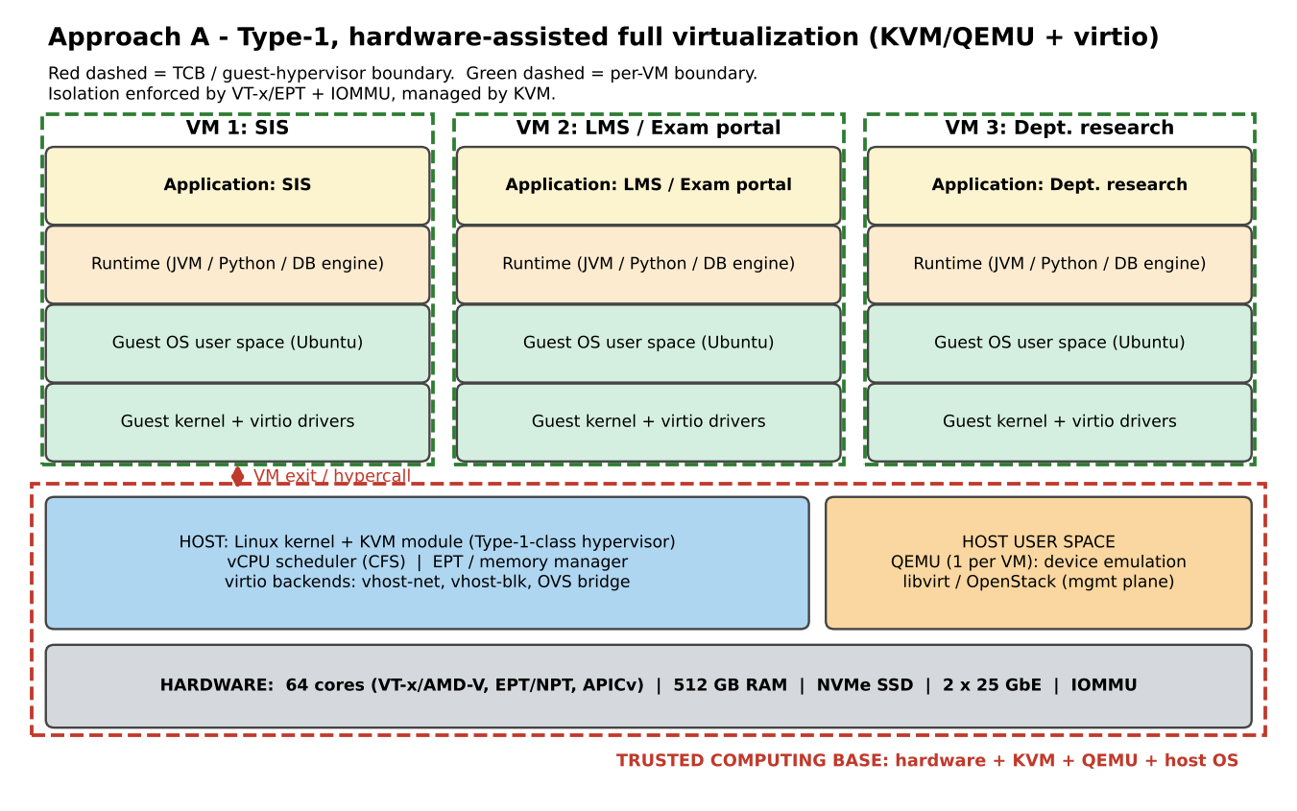
Figure 1. Layered architecture and trust boundaries of Approach A (KVM/QEMU).
Layers (bottom to top): hardware (VT-x, EPT, IOMMU) -> Linux+KVM hypervisor and host user space (QEMU per VM, libvirt) -> guest kernel -> guest OS user space -> runtime (JVM/DB) -> application.
Trust boundaries and isolation enforcer. (1) Guest <-> hypervisor: enforced by the CPU (VMX non-root mode, EPT permissions, IOMMU for DMA); all privileged guest actions cause a VM exit into KVM/QEMU. (2) VM <-> VM: each VM has a separate address space (EPT root) and kernel, so a compromised guest kernel is contained. The trusted computing base is hardware + KVM + QEMU + host OS; QEMU device emulation is the largest and historically most vulnerable part.
Table 5. Resource virtualization in Approach A.
Resource | How A virtualizes it
CPU | vCPUs are host threads scheduled by CFS; guest runs natively in VMX non-root mode; privileged instructions, interrupts and I/O cause VM exits (1.5 us each). Overcommit is time-slicing; waiting time is reported as steal time.
Memory | Two-dimensional paging: guest page tables (GVA->GPA) plus EPT (GPA->HPA). Page faults on EPT violations are handled by KVM. KSM merges identical pages; ballooning reclaims idle guest pages; host swap is the last resort.
Storage | virtio-blk/virtio-scsi: guest posts requests in a shared ring; a notification ("kick") causes one exit; QEMU iothread or vhost-blk performs the I/O on a qcow2/raw image or NVMe.
Network | virtio-net with vhost-net: shared rings, one exit per batch; host-side Linux bridge/Open vSwitch forwards to the physical NIC (or SR-IOV VF bypasses the host).

Relevance to EduCloud. It is the incumbent technology (the 400 VMs are VMs), gives the strongest hardware-enforced boundary between departments and for the SIS, and supports live migration for patching. Its weaknesses (guest sprawl, exit cost) are exactly what the audit and the registration-week slowdown point to.

1.3 Approach B - OS-level virtualization (containers)
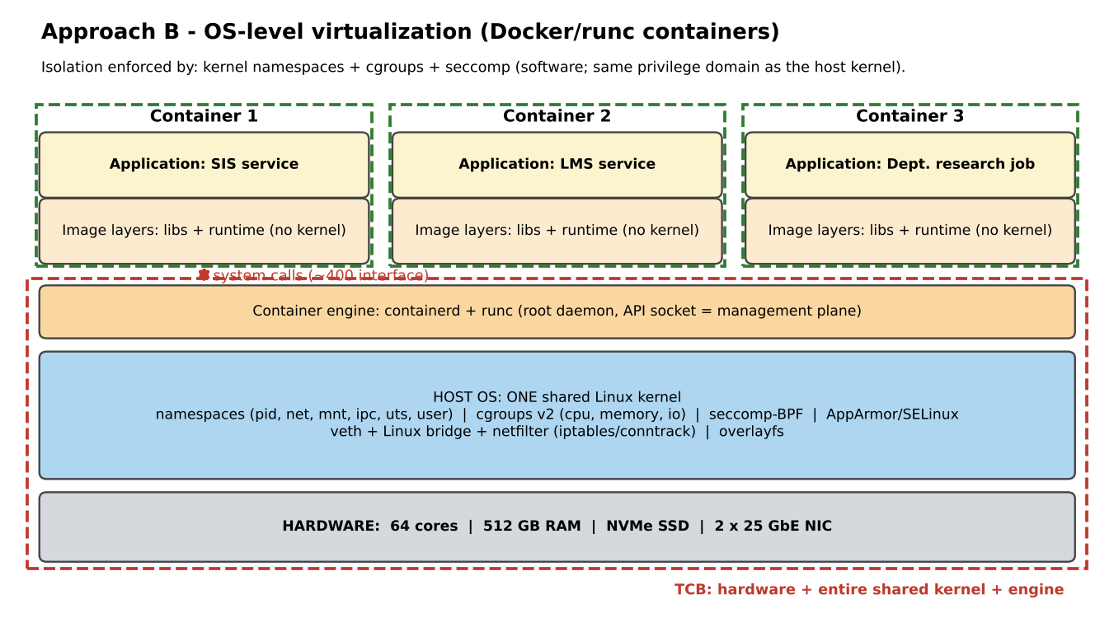
Figure 2. Layered architecture and trust boundaries of Approach B (containers).
Layers: hardware -> one shared Linux kernel (namespaces, cgroups, seccomp, LSM, veth/bridge/netfilter, overlayfs) -> container engine (containerd/runc) -> image layers (libraries + runtime) -> application. There is no guest kernel.
Trust boundaries and isolation enforcer. The only boundary between a container and the host or other containers is the system-call interface of the shared kernel, policed by namespaces (what a process can see), cgroups (how much it can use), capabilities/seccomp/LSM (what it may do). The enforcer is the host kernel itself, so any kernel vulnerability or misconfiguration breaks all isolation at once. The container engine daemon (root, API socket) is part of the management plane and the TCB.
Table 6. Resource virtualization in Approach B.
Resource | How B virtualizes it
CPU | No virtualization: container processes are ordinary host threads; the CFS cgroup controller enforces quota (cpu.max) and weight. No exits, no steal time (throttling instead).
Memory | Native page tables (no nested walk); the memory cgroup limits and accounts pages (memory.max); page cache and kernel text are shared across containers; swap/OOM-kill if over limit.
Storage | overlayfs (copy-on-write image layers) on the host file system, or bind-mounted volumes; the I/O cgroup controller throttles IOPS/bandwidth; I/O goes straight into the host block layer.
Network | Per-container network namespace connected by a veth pair to a Linux bridge; NAT/filtering by netfilter (iptables/conntrack); each hop adds per-packet CPU cost.

Relevance to EduCloud. Highest density and fastest start-up, ideal for stateless LMS/web tiers and for elastic registration-week scaling; but a single kernel shared by SIS and departmental research is hard to defend after the audit.

1.4 Approach C - Sandboxed container runtime (gVisor / runsc)
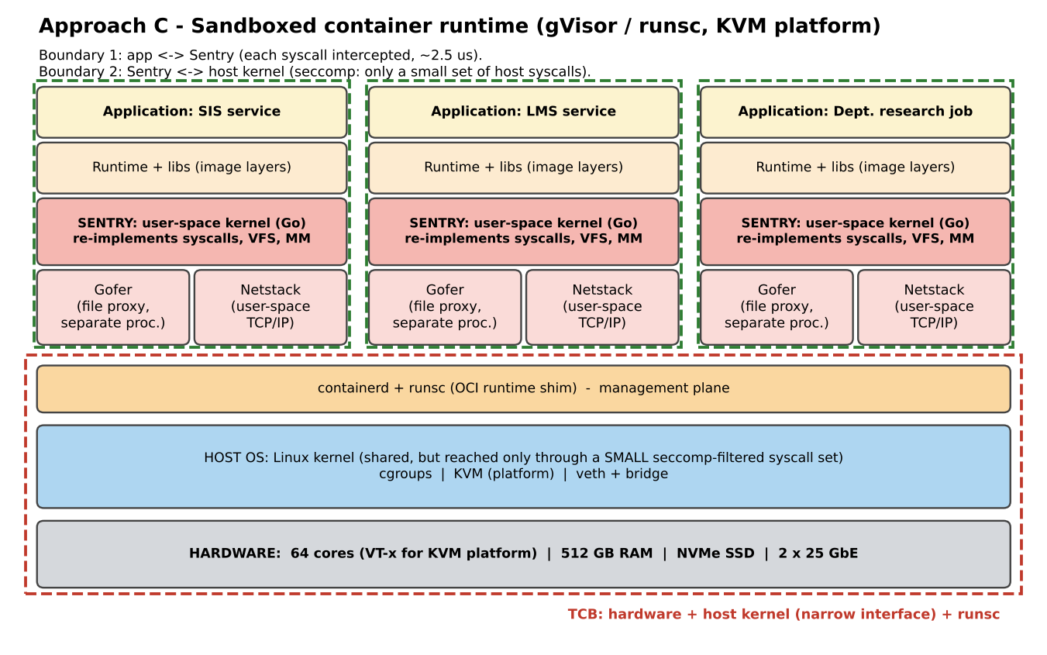
Figure 3. Layered architecture and trust boundaries of Approach C (gVisor).
Layers: hardware -> host Linux kernel (reachable only through a small seccomp-filtered syscall set) -> containerd + runsc -> per-container Sentry (user-space kernel written in Go, with its own VFS, memory manager and TCP/IP stack) and Gofer (file proxy) -> runtime/libraries -> application.
Trust boundaries and isolation enforcer. Two boundaries: (1) application <-> Sentry, where every system call is intercepted (KVM platform: a trap costing about one VM exit plus Sentry handling = 2.5 us); (2) Sentry <-> host kernel, restricted by seccomp to a small set of host syscalls. An attacker must break the memory-safe Sentry and then the host-kernel filter, so the application never talks to the real kernel directly.
Table 7. Resource virtualization in Approach C.
Resource | How C virtualizes it
CPU | Application threads run as sandboxed host threads/vCPU contexts; each syscall or fault traps into the Sentry; CPU quota enforced by host cgroups.
Memory | Sentry manages the application address space on top of a host memory file; page faults are handled in user space (extra cost); host cgroups bound the total.
Storage | File operations go app -> Sentry VFS -> Gofer (RPC over a socket) -> host file system; this extra hop costs roughly 12 us per request in the model.
Network | User-space netstack inside the Sentry (no host kernel TCP/IP for the sandbox) plus a veth/bridge to the host; per-packet cost is the highest of the three.

Relevance to EduCloud. It brings VM-like isolation of the kernel attack surface with container operations. It is a candidate for running untrusted code (student code-submission, exam autograding, external collaborators) where a shared kernel is unacceptable and a full VM per job is too heavy.

TASK 2 - Identify the Dominant Overhead Source (2 marks)
The dominant overhead is the mechanism that consumes most of the extra CPU time on the data path that EduCloud actually exercises: web + database traffic (registration week) with high packet and I/O rates. The breakdown below comes from the Task 3 model (Section 0 profiles).
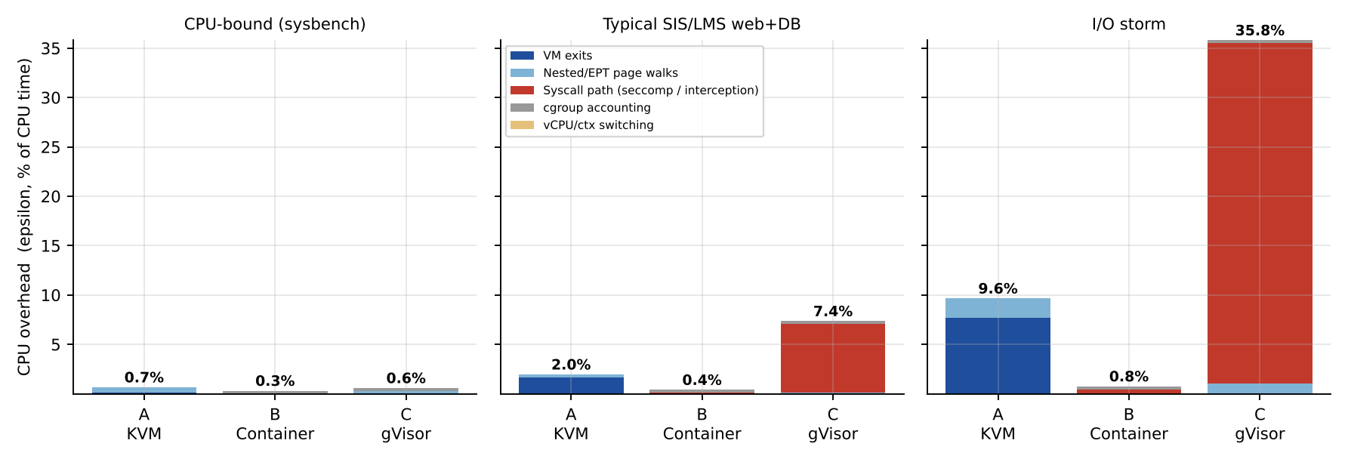
Figure 4. Model-predicted CPU overhead epsilon decomposed by source for each approach under three workload profiles.

2.1 Approach A: VM exits on the virtual-I/O path
- What it is. Every event the hardware cannot let the guest handle alone (virtio queue notification "kick", interrupt injection/EOI, HLT, IPIs, MSR/MMIO access) transfers control from the guest to KVM/QEMU and back: one VM exit costs 1.5 us (given), during which the vCPU does no guest work.
- Where it occurs. At the guest/hypervisor boundary (red line in Figure 1), on the paths CPU -> virtio-net/virtio-blk -> vhost/QEMU.
- Why it is the right focus. For the web profile exits account for 1.7% of CPU time versus 0.3% for nested page walks, and in an I/O storm 7.6% versus 2.0%. Nested (EPT) walks dominate only for memory-bound code (4.0%) and can be cut by huge pages; exits cannot be removed, only batched. EduCloud's problem (logins, DB queries, slow responses) is I/O-driven, so exits are the dominant, controllable term.
- How it scales. Exit frequency is proportional to the number of co-located VMs and to the I/O rate: exits/s = N v d (r_0 + x_io r_io). For N = 32 VMs at storm intensity this is 3.26 million exits/s, i.e. 4.9 host cores spent only on exits; at normal load with N = 60 it is 0.33 million/s (0.49 cores). The cost per exit also grows with overcommit because more vCPU switches mean cold caches (Task 3).

2.2 Approach B: virtual-switch / netfilter processing of the container network
- What it is. Every packet of a container crosses a veth pair, the Linux bridge and netfilter (conntrack, NAT rules) before reaching the NIC - about 0.45 us extra per packet when the rule set is short.
- Where it occurs. In the shared host kernel network stack between the container namespace and the physical NIC (the lower part of Figure 2).
- Why it is the right focus. CPU virtualization overhead is almost nil (0.4% in the web profile: cgroup accounting + seccomp), memory has no nested translation, and disk I/O goes straight to the host block layer. The network path is the only place where B adds a real per-operation cost, and the registration-week bottleneck is network- and I/O-bound.
- How it scales. Netfilter rules grow roughly linearly with the number of containers and published ports, so the cost per packet rises with n: from 1.26 us at n = 1 to 1.85 us at n = 60 (assumption 0.01 us per container). At line rate this consumes 4.1 cores at n = 60 versus 2.5 at n = 1. The cost also rises with packet rate because each packet traverses the whole chain.

2.3 Approach C: system-call interception by the Sentry
- What it is. Each system call of the sandboxed application is trapped and executed by the user-space Sentry instead of the host kernel: 2.5 us instead of 0.2 us - a factor of 12.5.
- Where it occurs. At the application <-> Sentry boundary, inside the sandbox, on every read/write/futex/epoll/network call.
- Why it is the right focus. A web/DB server issues tens of thousands of syscalls per second. The model gives 6.9% CPU overhead from syscalls in the web profile and 34.5% in a storm, while its page-walk and cgroup terms are small. CPU-bound code that makes almost no syscalls pays 0.02%, which shows that the overhead depends on the syscall rate, not on the CPU work.
- How it scales. Linearly with the syscall rate (and therefore with the I/O rate): overhead = r_sys x 2.3 us. It does not grow with the number of sandboxes per se (each has its own Sentry), but the Sentry/Gofer threads add CPU load, so the number of sandboxes a host can run before CPU saturation falls as the I/O rate rises.
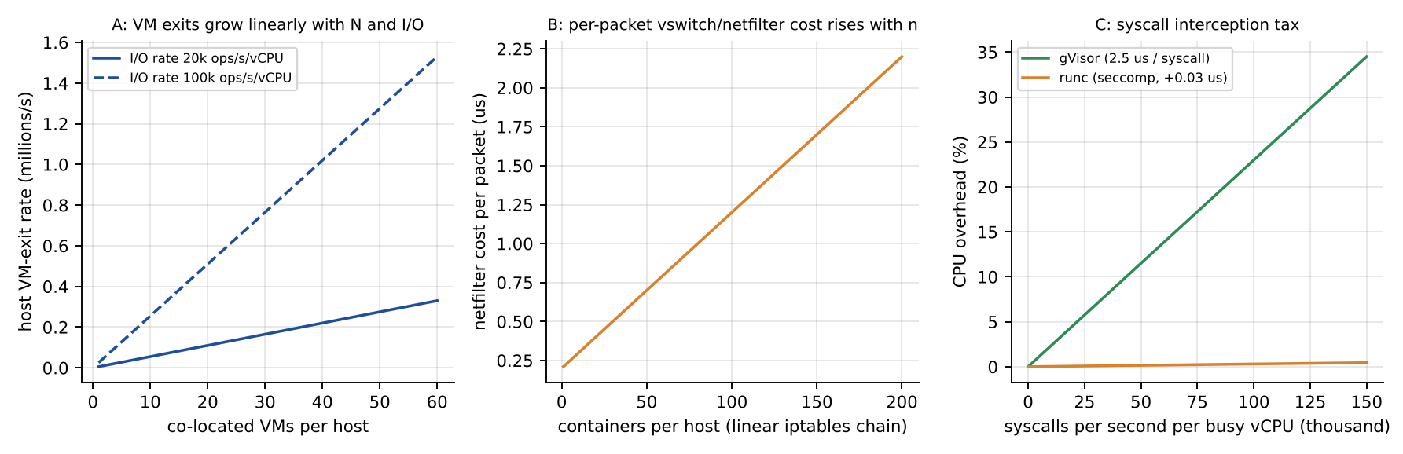
Figure 5. How each dominant overhead grows: exit rate with VMs and I/O (A), netfilter cost with container count (B), syscall tax with syscall rate (C).
Table 8. Summary of dominant overhead per approach.
Approach | Dominant overhead | Where | Scales with | Web / storm epsilon from it
A KVM VM | VM exits (virtio notifications, interrupts) | Guest <-> KVM/QEMU boundary | N x I/O rate | 1.7% / 7.6%
B Container | veth + bridge + netfilter processing | Shared-kernel network path | packet rate, number of containers (rules) | CPU 0.4 % / 0.8 %; +47 % per-packet cost at n = 60
C gVisor | Syscall interception (2.5 us vs 0.2 us) | App <-> Sentry boundary | syscall rate | 6.9% / 34.5%

TASK 3 - Build a Quantitative Performance Model (6 marks)
Notation: C = 64 cores, h = reserved cores, v = 2 vCPU per instance, rho = N v / C the vCPU:pCPU overcommit, d = duty cycle of a vCPU, N = instances per host, epsilon = fraction of CPU time lost to virtualization. The same symbols are used in the code (Appendix A).

3.1 CPU: effective per-VM capacity including steal time
Overhead per approach (sum of the dominant terms of Task 2 plus secondary terms):
eps_A = (r0 + x_io r_io) t_exit + mu t_walk + s(rho)
eps_B = eps_cg + r_sys (t_sec) + s_B(rho)
eps_C = r_sys (t_exit + t_sentry - t_sys) + 0.5 mu t_walk + eps_cg + s(rho)
where r0 = 1000 exits/s, x_io = 0.5, r_io = I/O ops per second, mu = TLB misses per second, and the scheduling term is s(rho) = c_sw(rho)/tau for rho > 1 (zero otherwise), with c_sw = 10 us + 5 us (rho - 1) for VMs/sandboxes and 3 us for containers, tau = 3 ms.
Share and steal. If N instances each want v d cores, total demand is N v d. The scheduler can supply C - h cores, so each vCPU receives the fraction
f(N) = min( 1 , (C - h) / (N v d) ), steal time s = 1 - f
and the effective useful CPU capacity of one instance (in physical-core equivalents) is
P_vm = v · d · f · (1 - eps)
For a saturated (CPU-bound, d = 1) instance at overcommit rho (N = rho C / v) this simplifies to P_vm = v (1 - eps(rho)) (C - h) / (rho C): capacity falls as 1/rho, plus the virtualization loss.
Worked example (A, rho = 4, CPU-bound). N = 4 x 64 / 2 = 128 VMs; f = (64 - 2)/(128 x 2 x 1) = 0.242, so steal = 75.8 %. eps = (1000 x 1.5 us) + (5x10^4 x 0.1 us) + s(4) = 0.15 % + 0.50 % + 0.83 % = 1.48%. P_vm = 2 x 1 x 0.242 x (1 - 0.0148) = 0.477 pCPU - the ideal 1/rho share would be 0.500.
Table 9. Effective useful capacity per 2-vCPU instance (pCPU), CPU-bound workload.
Approach | rho = 1:1 | rho = 2:1 | rho = 4:1 | rho = 8:1
A KVM | 1.925 (3% steal, eps 0.7%) | 0.958 (52% steal, eps 1.2%) | 0.477 (76% steal, eps 1.5%) | 0.237 (88% steal, eps 2.2%)
B Container | 1.963 (2% steal, eps 0.3%) | 0.980 (51% steal, eps 0.4%) | 0.490 (75% steal, eps 0.4%) | 0.245 (88% steal, eps 0.4%)
C gVisor | 1.957 (2% steal, eps 0.6%) | 0.974 (51% steal, eps 1.1%) | 0.485 (75% steal, eps 1.4%) | 0.241 (88% steal, eps 2.1%)
Ideal 2/rho | 2.000 | 1.000 | 0.500 | 0.250

Table 10. Same, web profile (d = 0.25). Up to 2:1 there is no steal because demand is below capacity - overcommit is "free" until aggregate demand reaches C - h.
Approach | rho = 1:1 | rho = 2:1 | rho = 4:1 | rho = 8:1
A KVM | 0.490 (0% steal, eps 1.9%) | 0.488 (0% steal, eps 2.5%) | 0.471 (3% steal, eps 2.8%) | 0.234 (52% steal, eps 3.5%)
B Container | 0.498 (0% steal, eps 0.4%) | 0.498 (0% steal, eps 0.5%) | 0.490 (2% steal, eps 0.5%) | 0.245 (51% steal, eps 0.5%)
C gVisor | 0.463 (0% steal, eps 7.4%) | 0.461 (0% steal, eps 7.8%) | 0.452 (2% steal, eps 8.2%) | 0.224 (51% steal, eps 8.9%)

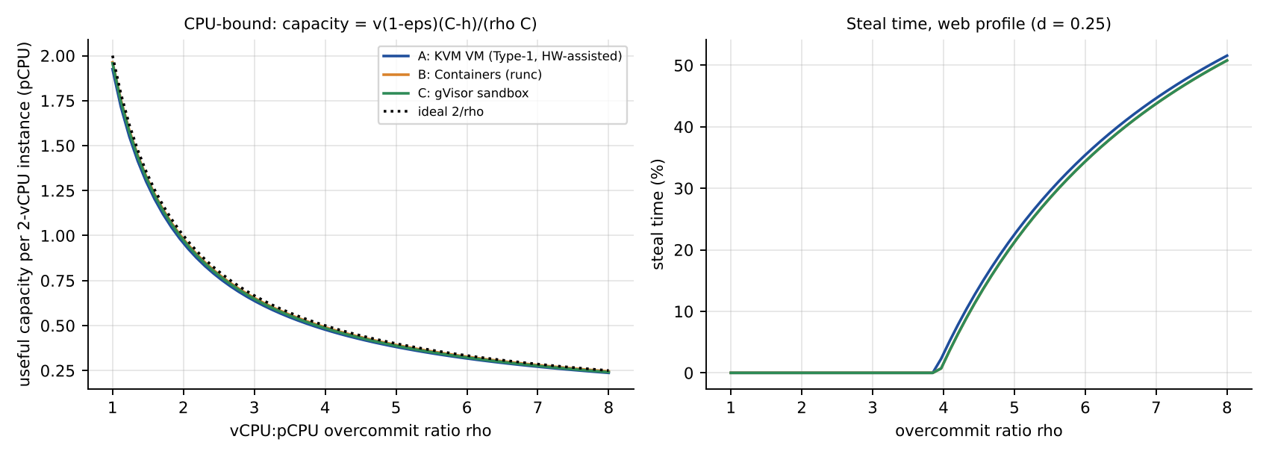
Figure 6. Per-instance capacity and steal time versus overcommit ratio.
Interpretation. Under saturation all approaches converge to the 1/rho line; the virtualization terms only shave a few percent (A 0.7% at rho = 1). The big differences appear when the workload makes many syscalls or I/Os: C loses 6.9% to interception for the web profile, A 1.7% to exits, B almost nothing.

3.2 Memory: maximum VMs per host before ballooning, swapping or sharing is needed
N_mem = floor( (R - R_h) / (m + o) )
A: (512 - 16)/(8 + 0.25) = 60.1 -> 60. B: (512 - 8)/(8 + 0.02) = 62.8 -> 62. C: (512 - 12)/(8 + 0.08) = 61.9 -> 61. Beyond this the host is memory-overcommitted and one of three mechanisms is needed: page sharing (KSM) N = (R - R_h)/(m(1 - sigma) + o) = 70 for A (containers already share the page cache; gVisor and B gain nothing); ballooning N = (R - R_h)/(m(1 - beta) + o) = 79 / 83 / 82; and host swapping, which must be avoided because of its cost:
EAT = (1 - p) t_mem + p t_swap (t_mem = 100 ns, t_swap = 80 us NVMe)
For p = 10^-5, 10^-4, 10^-3 the effective access time is 101, 108 and 180 ns, i.e. a swap-fault probability of only 0.1 % slows memory-bound code by 80 %. Key insight: with 8 GB instances the memory ceiling (about 60 per host) is reached long before the CPU ceiling at 2:1 overcommit (64 VMs would only need rho = 2). Hence memory, not CPU, limits density.
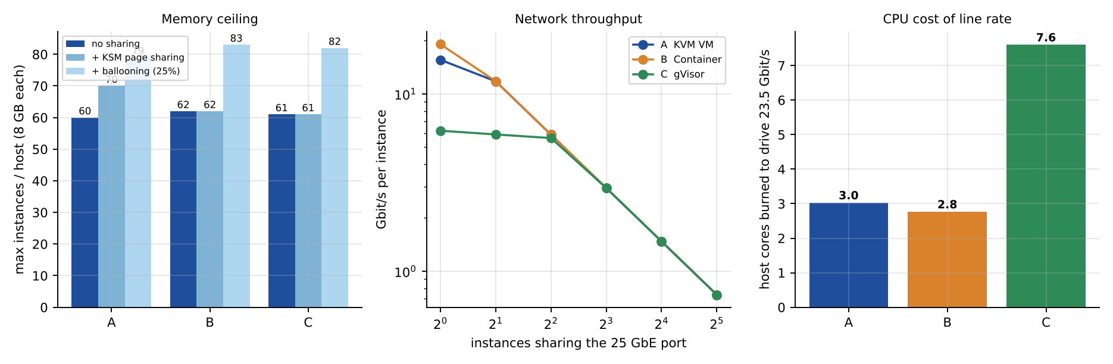
Figure 7. Left: memory ceiling per host. Centre: network throughput per instance versus number of instances sharing a 25 GbE port. Right: host cores consumed to drive the line rate.

3.3 I/O and network: throughput versus number of instances sharing the device
Per-packet CPU cost of the data path (microseconds), assuming MTU-size packets without offload (conservative):
Table 11. Network data-path cost per packet.
Approach | Build-up of per-packet cost c_pkt | Value
A KVM + vhost-net | 0.80 native stack + 0.35 vhost copy + t_exit/16 (batch) + 0.30 OVS fast path | 1.544 us
B veth + netfilter | 0.80 native + 0.25 veth/bridge + (0.20 + 0.01 n) netfilter (n = 16) | 1.410 us
C gVisor netstack | 0.80 + 2.50 user-space TCP/IP + (t_gv - t_sys)/4 syscall per 4 packets | 3.875 us

T(n) = PKT · min( L_eff/PKT , min(n v, C - h) / c~(n) ) / n , c~(n) = c_pkt (1 + kappa log2 n)
The device (25 GbE, usable L_eff = 25 x 0.941 = 23.5 Gbit/s) is shared fairly; each instance gets at most the CPU-limited rate and at most L_eff/n. kappa (0.02, 0.02, 0.05) models cache/lock contention per doubling of n. Disk is modelled identically with c_io = 9.75 / 6.3 / 20.3 us per 4 KiB request (A: 6 + 2 t_exit/4 + 3; B: 6.3; C: 6 + 2.3 + 12 for the Gofer RPC) and a device limit of 600 k IOPS.
Table 12. Predicted network and disk throughput per instance versus number of instances sharing the device.
Instances n | 1 | 2 | 4 | 8 | 16
Network Gbit/s per instance - A | 15.55 | 11.77 | 5.88 | 2.94 | 1.47
Network Gbit/s per instance - B | 19.05 | 11.77 | 5.88 | 2.94 | 1.47
Network Gbit/s per instance - C | 6.19 | 5.90 | 5.63 | 2.94 | 1.47
Disk kIOPS per instance - A | 205 | 201 | 150 | 75 | 38
Disk kIOPS per instance - B | 317 | 300 | 150 | 75 | 38
Disk kIOPS per instance - C | 99 | 94 | 90 | 75 | 38

Worked example (network, A, n = 2). CPU limit: min(2 x 2, 62)/(1.544 us x 1.02) = 2.54 Mpps = 30.5 Gbit/s; line limit 23.5 Gbit/s -> the NIC saturates and each VM gets 23.5/2 = 11.77 Gbit/s. For C at n = 1: 2 cores / 3.875 us = 0.516 Mpps = 6.19 Gbit/s - CPU-limited, far below line rate. Insight: once n >= 2 (A, B) or n >= 4 (C) the device, not the virtualization layer, caps throughput - but reaching line rate costs 3.0 / 2.8 / 7.6 host cores (A/B/C), which comes out of the cores available to VMs.

3.4 Density under a service-level target (<= 10 % degradation)
Degradation relative to bare metal with the same demand is D(N) = 1 - (1 - eps) f(N). Requiring D <= 10 % and substituting f gives the CPU-limited density
N_cpu = floor( (C - h)(1 - eps) / ( (1 - 0.10) v d ) ) (valid if eps < 10 %)
(eps itself depends on N through the scheduling term, so the code solves it by scanning N.) The host density is the smallest of the CPU, memory and network limits:
N_max = min( N_cpu , N_mem , N_net ), N_net = floor(L_eff / b_inst) (b_inst = 0.2 Gbit/s average per SIS/LMS VM)
Table 13. Instances per host that meet the 10 % target (2 vCPU / 8 GB each).
 | N_cpu normal (d = 0.25) | N_cpu 3x peak (d = 0.75) | N_mem | N_net (0.2 Gbit/s) | N_max normal | N_max peak
A KVM | 133 | 44 | 60 | 117 | 60 | 44
B Container | 139 | 46 | 62 | 117 | 62 | 46
C gVisor | 128 | 43 | 61 | 117 | 61 | 43

Worked example (A, peak). eps ~ 1.95 %: N_cpu = 62 x 0.9805 / (0.9 x 2 x 0.75) = 45 (the exact scan gives 44 because eps rises with overcommit). Memory allows 60, so the peak density is 44 VMs/host, versus 60 at normal load. For the whole cluster of 16 hosts: normal load 16 x 60 = 960 VMs, peak about 16 x 44 = 704 VMs - the current 400 VMs fit, which suggests that the registration-week failures come from the network/I-O path, shared storage and per-VM sizing rather than from raw core count.
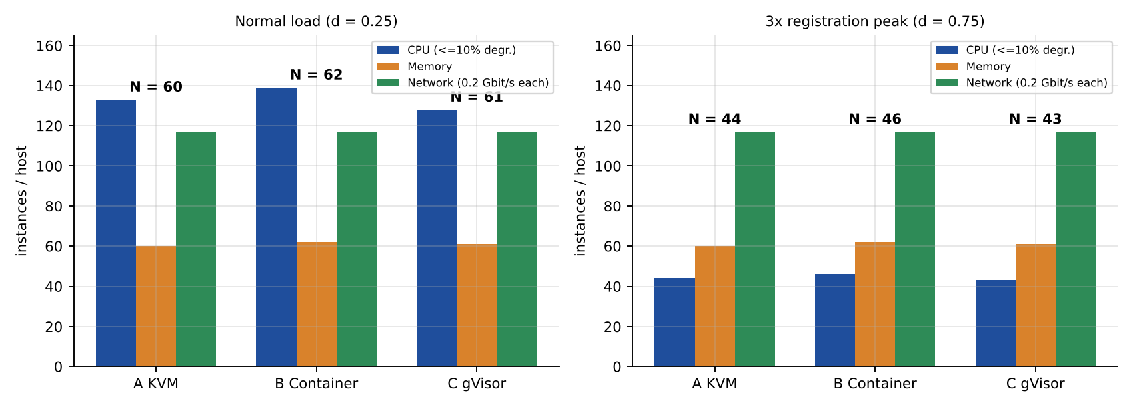
Figure 8. Per-host density limits at normal load and at the 3x registration peak.

TASK 4 - Analyse Performance Under Different Operating Conditions (4 marks)
Scenarios are evaluated with the Task 3 model. Bare-metal reference for the web profile: mean response time = S0/(1 - d) = 15 ms/(1 - 0.25) = 20 ms (p95 = 3 x mean = 60 ms) at normal load and 30 ms (p95 90 ms) at d = 0.5.
Table 14. Operating conditions.
Condition | Definition used in the model
Best case | N = 16 instances (rho = 0.5), pinned vCPUs, 2 MiB/1 GiB huge pages (mu reduced 10x), no co-tenant interference
Typical case | Registration-week mixed web + database load: N = 48 instances per host, d = 0.5 (rho = 1.5), web profile
Worst case 1 | Noisy neighbour: memory-bandwidth hog using u = 30 % of host bandwidth + shared-kernel interference
Worst case 2 | Memory overcommit with host swapping: page-fault probability about 10^-3
Worst case 3 | I/O storm: all N = 32 instances at storm intensity
Worst case 4 | Live migration of an 8 GB VM during peak (dirty rate 3.2 Gbit/s, migration bandwidth 9.6 Gbit/s)

4.1 Best case
What happens inside the layer. With pinned vCPUs and huge pages, A takes few EPT misses (mu from 3x10^4 to 3x10^3 per second) and no vCPU is ever descheduled; exits remain only for timers and virtio kicks. B runs native code with only cgroup accounting. C still intercepts every syscall. Overhead: A 1.7%, B 0.4%, C 7.2%. Latency (mean / p95): A 20.5 / 61.6 ms, B 20.1 / 60.3 ms, C 22.2 / 66.5 ms against 20.0 / 60.0 ms bare metal. Throughput is within 0.4-7 % of bare metal. Why: the dominant overhead of each approach is only incurred when the workload exercises it - A pays for exits only per I/O, B pays for netfilter only per packet, C pays 2.3 us only per syscall - so low-I/O, low-syscall, well-placed work sees the smallest penalty. In the best case a single network flow reaches 15.5 / 19.0 / 6.2 Gbit/s (A/B/C).

4.2 Typical case: registration-week mixed load
What happens inside the layer. With 48 instances on 62 usable cores and d = 0.5, demand is 48 x 2 x 0.5 = 48 cores - below capacity, so the scheduler gives every vCPU what it asks for and steal time is zero. Overhead comes from I/O exits (A), seccomp/cgroup (B) and syscall interception (C). Degradation: A 2.4%, B 0.5%, C 7.8% (all within the 10 % target for A and B; C at 7.8% has little headroom). Latency (mean / p95): A 32.2 / 96.0 ms, B 30.9 / 92.1 ms, C 36.3 / 108.1 ms versus 30 / 90 ms bare metal. Why latency moves more than throughput: the vCPU is half busy, so a request waits behind queued work (M/M/1 factor 1/(1 - U)); any inflation of service time S -> S/(1 - eps) raises U = d/(1 - eps) and the queueing term amplifies it. Latency is therefore the first metric to degrade, well before the throughput target of 10 % is broken. Plus a wake-up delay of about 0.75 ms appears because rho > 1 means vCPUs sometimes wait for a free pCPU.

4.3 Worst cases
(1) Noisy neighbour. A co-located memory-bandwidth hog consumes u = 30 % of host memory bandwidth. Memory accesses see a queueing slowdown 1/(1 - u) = 1.43; if a victim spends 30 % of its time on memory, its slowdown is 1 + 0.3 (1.43 - 1) = 1.13. B adds a shared-kernel interference term (+0.06: dentry/inode locks, softirq, page-cache contention), C +0.02 (its own kernel but the same host I/O path). Predicted degradation: A 13.5%, B 16.3%, C 19.7%. Inside the layer: cache and memory-controller contention is invisible to the hypervisor and the container runtime alike (it is hardware sharing), so no approach avoids the 13 % term; only the shared-kernel part differs, which is why containers are worst for the *same* interference. Mitigations: Intel RDT/CAT cache partitioning, memory-bandwidth allocation, pinning, dedicated hosts.
(2) Memory overcommit with swapping. If the host must swap, a fraction p of accesses becomes a major fault of 80 us. For A the host chooses pages blindly (the guest cannot tell which pages are cold - 'double paging'), so I assume p = 1.5x10^-3 versus 1.0x10^-3 for B (cgroup reclaim uses per-container LRU) and 1.3x10^-3 for C. EAT = 220 / 180 / 204 ns, giving degradation 28% / 20% / 30% (A/B/C). Latency is hit even harder: each faulting request stalls for tens to hundreds of microseconds per page, so the p95 tail is dominated by the swap tail, not by the mean. This is why the memory ceiling of Task 3.2 must be a hard admission-control limit for the SIS pool.
(3) I/O storm. At storm intensity (1x10^5 I/O ops/s and 1.5x10^5 syscalls/s per busy vCPU) the dominant overheads explode: eps = 9.7% (A), 0.8% (B), 35.8% (C); with 32 instances all busy the demand (64 cores) also exceeds the 62 available, so steal is 3.1% / 1.6% / 1.6%. Degradation: A 12.5% (violates the 10 % target), B 2.3%, C 36.8%. Since d = 1 the vCPU utilisation reaches 100 %, queues grow without bound and requests time out: this is the failure mode users saw as 'failed logins'. A pays its exit tax per I/O, C pays its syscall tax per I/O (3x worse than A), B barely notices because its path is native.
(4) Live migration during peak. Pre-copy sends the 8 GB of RAM at B_m = 9.6 Gbit/s (40 % of the 23.5 Gbit/s port, throttled) while the guest keeps dirtying pages at r = 3.2 Gbit/s. Total time T = (M/B_m)/(1 - r/B_m) = (64/9.6)/(1 - 0.333) = 10 s, downtime about 124 ms. Inside the layer, dirty-page tracking write-protects guest pages, so every first write per round is an EPT-violation exit: 3.2 Gbit/s / 4 KiB = 0.10 M faults/s x 1.5 us = 7.3 % of the VM's two vCPUs, and the migration stream takes 9.6 of 23.5 Gbit/s from every other VM on the host (their per-instance share falls by 41 %). If the dirty rate rises to 8 Gbit/s, T becomes 40 s with 1.2 s downtime; if r >= B_m, pre-copy never converges and auto-converge throttling of the guest is needed. Containers (B, C) have no true live migration: a checkpoint/restore freezes the process tree for about 8 GB / 9.6 Gbit/s = 6.7 s, so they are normally rescheduled instead - an operational advantage for stateless tiers and a disadvantage for the stateful SIS.
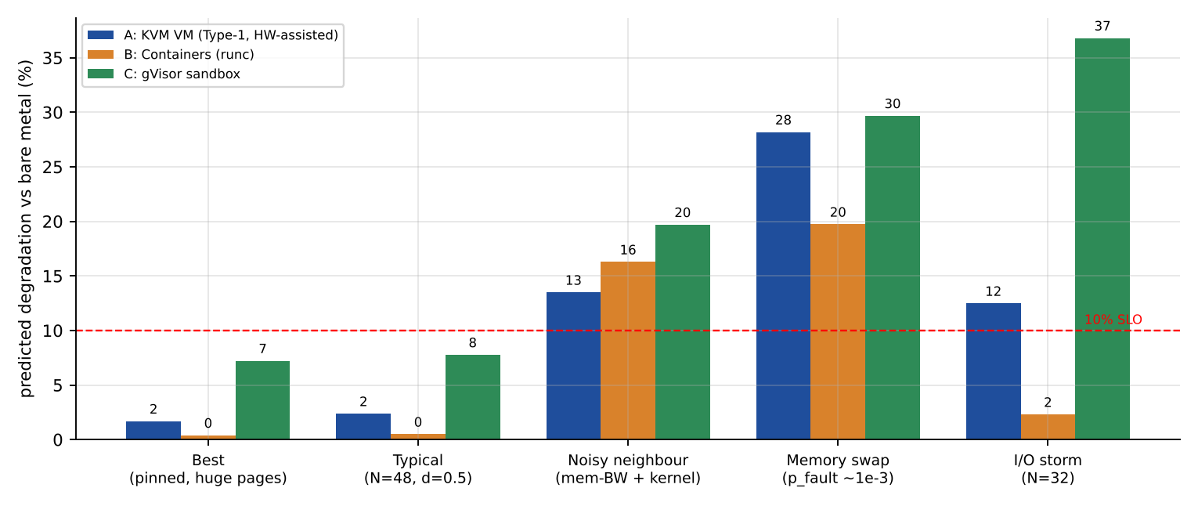
Figure 9. Predicted degradation versus bare metal in the five conditions (Task 3 model). The 10 % target is exceeded by every approach in at least one worst-case.
Table 15. Summary of predicted degradation (the explanation is in the text above, the table only summarises).
Condition | A KVM | B Container | C gVisor | Reason for the ranking
Best (epsilon) | 1.7% | 0.4% | 7.2% | overhead only on exercised paths
Typical (degradation) | 2.4% | 0.5% | 7.8% | no steal; per-I/O taxes differ
Noisy neighbour | 13.5% | 16.3% | 19.7% | hardware contention same; B shares kernel
Memory swap | 28% | 20% | 30% | A double paging; B per-cgroup reclaim
I/O storm | 12.5% | 2.3% | 36.8% | exits vs native vs 12.5x syscalls

TASK 5 - Security Threat and Vulnerability Analysis (3 marks)

5.1 Attack surface per approach
Table 16. Attack surface mapped to the architectures of Task 1.
Surface | A KVM VM | B Container | C gVisor
Hypervisor / isolation core | KVM kernel module + QEMU; small, hardware-assisted, but QEMU device emulation is large (e.g. VENOM, CVE-2015-3456, floppy controller) | No separate layer: the entire host kernel (tens of millions of lines, ~400 syscalls) is the boundary (e.g. Dirty COW CVE-2016-5195, Dirty Pipe CVE-2022-0847) | Sentry (memory-safe Go) re-implements syscalls; host kernel sees only a small seccomp-filtered set
Device emulation | virtio/QEMU per VM; IOMMU limits DMA | None (native drivers) | Netstack + Gofer in user space
Shared kernel | No - each VM has its own kernel | Yes - one kernel for all tenants | Partly - host kernel shared, but app does not call it directly
Management plane | libvirt/OpenStack APIs, QEMU monitor sockets | Docker/containerd daemon (root), docker.sock = root on host | Same daemon/shim as B plus runsc
Images and snapshots | Large qcow2 images incl. OS, credentials, memory snapshots; copied freely | Layered, content-addressed images; small, verifiable by digest | Same as B
Virtual network | OVS/Linux bridge, VLAN/VXLAN, per-VM vNIC with filtering possible | Flat docker0 bridge by default; CAP_NET_RAW enables ARP spoofing | Own netstack; no raw sockets by default; same host bridge

5.2 Threat model: eight threat categories
Exposure is scored 1 (low) to 5 (high) from the architecture and trust boundary of each approach; the weights w_t reflect the impact on confidentiality (C), integrity (I) and availability (A) of student records.
Table 17. Threat model and exposure scores.
Threat | A | B | C | w_t | Why (architecture and trust boundary)
T1 Isolation-boundary escape | 2 | 5 | 2 | 0.18 | A: needs a bug in KVM/QEMU, boundary enforced by hardware. B: a single kernel/runc bug gives host root (e.g. runc CVE-2019-5736). C: must break Sentry, then the host seccomp filter.
T2 Cross-tenant side channels | 4 | 5 | 4 | 0.14 | All share caches, memory buses and SMT siblings (L1TF CVE-2018-3646, MDS, Spectre CVE-2017-5753/5715). B worst: attacker also reaches kernel gadgets/data through native syscalls.
T3 Hypervisor / runtime / kernel vulnerability | 3 | 4 | 3 | 0.14 | A: KVM + QEMU codebase. B: whole kernel + runc, largest exposed surface. C: Sentry is new code but memory-safe and not in the host kernel.
T4 VM sprawl & unpatched guests | 5 | 3 | 3 | 0.14 | A highest: each VM has its own kernel to patch - the audit found outdated guest kernels. B: kernel patched once per host, stale base images remain. C: no guest kernel; images still stale.
T5 Image tampering / uncontrolled copies | 4 | 2 | 2 | 0.08 | A: big mutable disk images, copied freely between teams. B/C: layered digest-addressed images that can be signed (cosign).
T6 Insecure live migration / checkpoint | 4 | 1 | 2 | 0.10 | A: RAM and device state cross the network in clear unless TLS is on. B/C: no live migration (checkpoint files only for C).
T7 Virtual-network sniffing & spoofing | 3 | 4 | 3 | 0.08 | B: flat bridge + NET_RAW. A: per-VM vNIC, filter rules possible, but shared OVS. C: own stack, no raw sockets.
T8 Management-plane compromise | 3 | 4 | 4 | 0.14 | B: Docker socket/daemon is root on host. A: libvirt/QEMU monitor. C: same daemon as B.

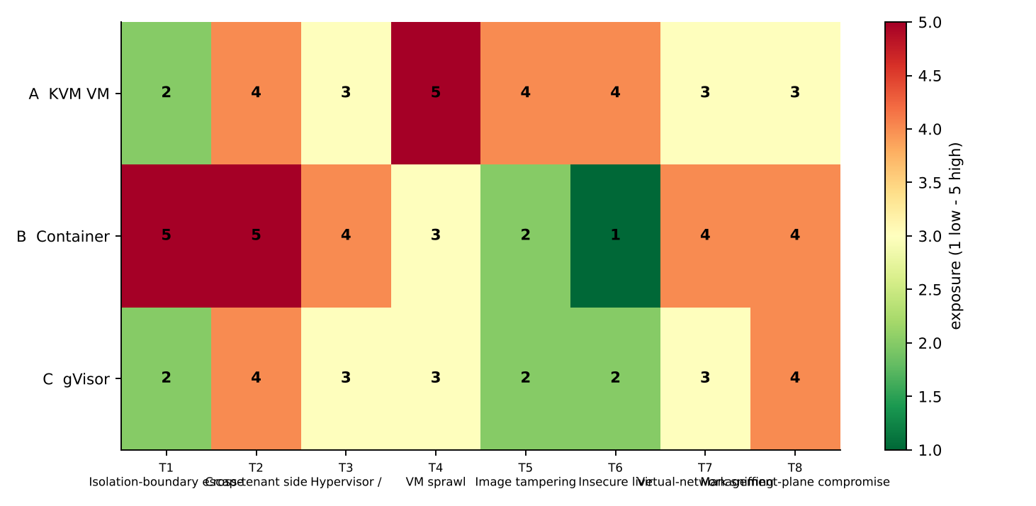
Figure 10. Exposure heat map (green = low, red = high).

5.3 Impact on confidentiality, integrity and availability of student records
Table 18. CIA impact of each threat on student records.
Threat | C | I | A | Student-record consequence
T1 Escape | High | High | High | Attacker with a foothold in a co-hosted tenant reads/modifies SIS data on the host; B: one exploit compromises every container on the node.
T2 Side channel | High | Low | Low | Leakage of keys/session tokens/DB buffers across tenants; no trace left.
T3 Hypervisor/runtime vulnerability | High | High | High | Host-level compromise or crash of all tenants (denial of service during registration).
T4 Sprawl / unpatched guests | High | High | Med | Known-CVE exploit of an old guest kernel gives direct access to the SIS database VM.
T5 Image tampering | Med | High | Med | Backdoored or stale image deployed under SIS name; copied images may contain real records.
T6 Insecure migration | High | High | Low | Memory pages (including plaintext records and keys) can be sniffed or modified in transit.
T7 Network sniffing/spoofing | High | Med | Med | Interception/redirection of login traffic; ARP spoofing for session theft.
T8 Management compromise | High | High | High | Full control of all instances, snapshots and credentials.

5.4 Justified comparison
Splitting the threats into architectural (T1, T2, T3, T7, T8 - decided by the design) and operational (T4, T5, T6 - decided by process and removable by Task 7 measures), the weighted architectural exposure is A 0.59, B 0.89, C 0.63, giving architectural isolation scores I = 1 - E of 0.41 (A), 0.11 (B), 0.37 (C). The operational exposure is highest for A (0.89) because of VM sprawl, unsigned images and clear-text migration - exactly the findings of the internal audit - but these are the cheapest to fix. Conclusion: B is far more exposed than A and C because its boundary is the shared kernel; A and C are comparable architecturally (A has a hardware boundary, C a smaller host-kernel interface); A's largest weaknesses are operational and fixable.

TASK 6 - Formulate the Isolation-Performance Trade-off (3 marks)
The model below is built from the Task 3 expressions (N_cpu, N_mem, D) and the Task 5 exposure scores - not from a template.

6.1 Sets, decision variables, parameters
Table 19. Decision variables and parameters.
Symbol | Meaning | Source
k in K = {SIS, LMS, RES, EXT} | tenant classes (SIS+LMS+exam = production; RES = internal research; EXT = external Spark) | scenario
x_{k,a} in {0,1} | tenant class k runs on approach a in {A, B, C} | decision
y_k in {0,1} | SMT off (1) or on (0) on the hosts of class k | decision
z_k in {0,1} | dedicated host pool (1) or shared with other classes (0) | decision
n_k (integer) | instances of class k per host | decision
H_k (integer) | hosts in the pool of class k | decision
N_k | number of instances of class k (production 260, research 140, ...) | parameter
N_cpu(a, y, d_k), N_mem(a) | density limits from Task 3 (SMT-off C = 64, SMT-on 80 core-equivalents) | Task 3
e_{a,t}, w_t | exposure scores and impact weights | Task 5
lambda_k | policy weight: how many hosts one unit of isolation loss is worth for class k (SIS 40) | policy choice
c_h | cost of one host (1 host-equivalent) | unit

6.2 Isolation score
I(a, y, z) = 1 - [ sum_{t in arch} w_t e'_{a,t} ] / [ 5 sum_{t in arch} w_t ], e' = e - y·[t = T2] - z·[t in {T1, T2, T3}] (floored at 1)
SMT off removes the sibling-thread channel (T2 - 1); a dedicated pool removes co-residence with less-trusted tenants (T1, T2, T3 - 1 each). Values: A 0.412 base, 0.453 SMT-off, 0.547 dedicated, 0.588 both; B 0.106 -> 0.282; C 0.371 -> 0.547.

6.3 Objective, constraints and decision function
minimise Z = c_h · sum_k H_k + sum_k lambda_k · ( 1 - I(a_k, y_k, z_k) )
Constraints (for every class k):
- Density: n_k <= min( N_cpu(a_k, y_k, d_k), N_mem(a_k) ) and H_k >= ceil(N_k / n_k) (this embeds the <= 10 % performance degradation target of Task 3).
- Isolation requirement: I(a_k, y_k, z_k) >= I_min,k (SIS: I_min = 0.50, so shared-pool configurations with SMT on are infeasible).
- No co-residence of untrusted and regulated classes: z_SIS = 1 and z_EXT = 1 (data-protection regulation, Task 12).
- Capacity: sum_k H_k <= 16 hosts (existing cluster) - or the number of hosts that must be purchased is reported.
- Memory: n_k (m_k + o_a) + R_h,a <= 512 GB.
The cost function combines infrastructure cost (hosts, which rises when SMT is switched off or pools are dedicated because density falls) and a security-risk cost (isolation loss weighted by how valuable the data is). A tenant class with more valuable data gets a larger lambda_k and is pushed towards stronger isolation, accepting more hosts.

6.4 Numerical evaluation for the SIS class (260 instances at 3x peak)
Table 20. All 12 configurations for the SIS class, sorted by Z. Infeasible rows keep their Z for comparison.
Approach | SMT | Dedicated pool | n per host | Hosts | I | I >= 0.50 | Z (lambda = 40)
A KVM | off | yes | 44 | 6 | 0.588 | yes | 22.47
A KVM | on | yes | 56 | 5 | 0.547 | yes | 23.12
C gVisor | on | yes | 53 | 5 | 0.506 | yes | 24.76
C gVisor | off | yes | 43 | 7 | 0.547 | yes | 25.12
A KVM | off | no | 44 | 6 | 0.453 | NO | 27.88
A KVM | on | no | 56 | 5 | 0.412 | NO | 28.53
C gVisor | on | no | 53 | 5 | 0.371 | NO | 30.18
C gVisor | off | no | 43 | 7 | 0.412 | NO | 30.53
B container | off | yes | 46 | 6 | 0.282 | NO | 34.71
B container | on | yes | 58 | 5 | 0.241 | NO | 35.35
B container | off | no | 46 | 6 | 0.147 | NO | 40.12
B container | on | no | 58 | 5 | 0.106 | NO | 40.76

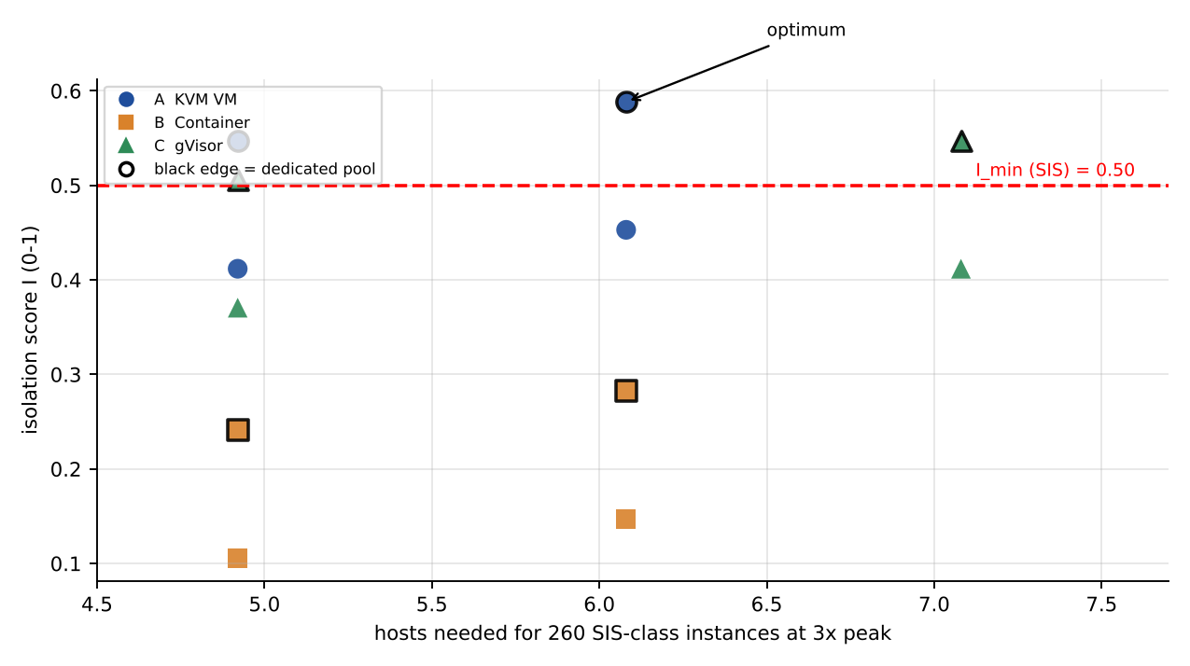
Figure 11. Isolation score versus hosts needed for the SIS class; black edge = dedicated pool.
Result. The minimum-cost feasible design is Approach A on a dedicated pool with SMT off (6 hosts, I = 0.588, Z = 22.47). Containers (B) never reach I_min even with every isolation measure, because their boundary is the shared kernel. gVisor (C) is feasible but needs more hosts because of its overhead. Sensitivity: switching SMT off costs one extra host (5 -> 6) and gains 0.041 in I, so it pays off only when lambda > 1/0.041 = 24.3; for the regulated SIS (lambda = 40) SMT-off wins, for the internal research class (lambda about 3) SMT stays on.

TASK 7 - Evaluate Mitigation Strategies (4 marks)
Seven mitigations for the Task 5 threats are evaluated. Cost is computed with the Task 3 model for the SIS pool at the 3x registration peak (d = 0.75) unless noted.
Table 21. Mitigation evaluation.
Mitigation | Threat / why applicable | Residual risk | Modelled cost (Task 3 model) | Acceptable for SIS?
M1 Disable SMT (A) | T2: removes the sibling-thread channel used by L1TF/MDS-type attacks between VMs on the same core | LLC, memory-bus and Spectre-v1 channels remain; attacker VMs on other cores | Capacity 80 -> 64 core-eq (-20 %); N_cpu(peak) 56 -> 44 VMs/host (-21.4 %); SIS hosts 5 -> 6 | Yes: 1 extra host for a large reduction in T2 exposure (Task 6 break-even lambda 24 < 40)
M2 L1D flush on VM entry + KPTI/retpoline | T2/T3: stops L1TF/Meltdown-class leaks across the guest/host boundary and across processes | Needs microcode/patch discipline; no help against LLC channels | t_exit 1.5 -> 2.5 us: A eps(web) 1.95% -> 3.05%, storm 9.7% -> 14.8%; per-packet 1.54 -> 1.61 us (+4 %). KPTI (+0.15 us/syscall): B 0.39% -> 0.84%, C 7.35% -> 7.80%; N_cpu unchanged (44) | Yes: about 1 point of CPU, density unchanged
M3 Dedicated host pools for SIS (and separate pool for external tenants) | T1/T2/T3: attacker VM is never co-resident with SIS | Hardware/firmware bugs, insider, management plane | Fleet of 400 VMs: shared pool 7 hosts -> separate pools 6 (SIS, SMT off) + 3 (research) = 9 hosts (+29 %) - stranded capacity | Yes, mandatory under the new regulation; fits in the 16 hosts
M4 Sandboxed runtime for container tenants (B -> C) | T1/T3: replaces shared-kernel boundary by Sentry + seccomp | Sentry bugs, host-kernel residual, same hardware channels | eps(web) 0.39% -> 7.35%; storm 0.8% -> 35.8%; cores to drive line rate 2.8 -> 7.6; N_cpu(peak) 46 -> 43 | Only for web-tier containers; not for I/O-heavy DB (storm overhead 36 %)
M5 Hardware memory encryption (SEV-SNP / TDX) | T2/T3/T8: hypervisor and co-tenants cannot read guest RAM; also protects snapshots in memory | Side channels, denial of service, device/IO attacks | +3 % on the memory-bound 30 % of time = +0.9 % CPU; KSM impossible and +0.1 GB/VM metadata: N_mem 60 -> 59 (-1.7 %); 70 -> 59 (-15.7 %) if KSM had been relied on | Yes for external tenants; optional for SIS (no KSM used)
M6 Image signing + micro-segmentation | T5/T7: only signed images start; per-VM firewall isolates SIS flows; stops ARP/sniffing across tenants | Compromised signing key; flows permitted by policy | Image signing: no run-time cost (verified at deploy). Micro-segmentation adds 0.15 us/packet: 1.544 -> 1.694 us (+9.7 %); cores to drive line rate 3.03 -> 3.32 (+0.3 core) | Yes: negligible
M7 Encrypted live migration (TLS), inside a pool only | T6: protects RAM contents in transit | Endpoint compromise; migration metadata | Single TLS stream limited to 6.4 Gbit/s: migration 10 s -> 20 s, downtime 124 -> 425 ms; with 3 parallel (multifd) streams: 10 s, 124 ms (+~0.8 core while migrating) | Yes with multifd; never migrate during the 3x peak

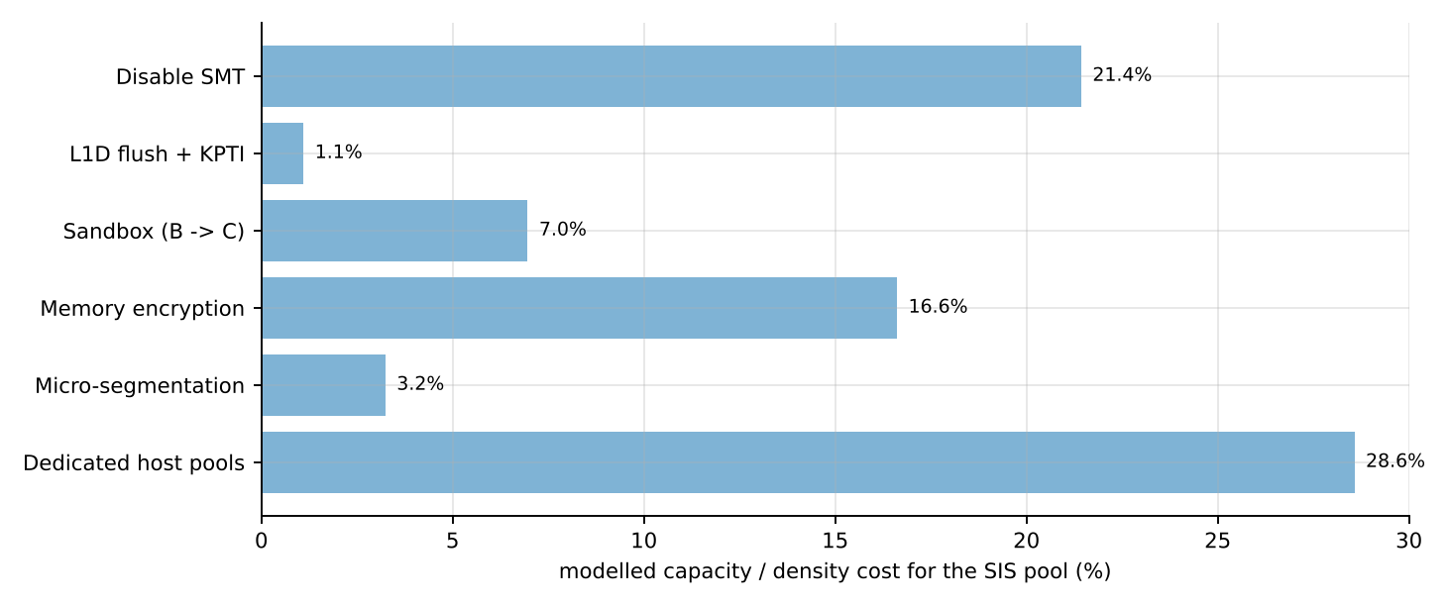
Figure 12. Modelled capacity/density cost of each mitigation for the SIS pool (M7 and image signing cost no density).
Combined SIS package (M1 + M2 + M3 + M6 + M7, optionally M5): N_cpu(peak) with SMT off and t_exit = 2.5 us is 44 VMs/host versus 56 originally (SMT on, no mitigation) - a 21 % density loss, i.e. 5 -> 6-7 hosts for the 260 SIS-class VMs. This is a modest, quantified price for a large reduction in T1/T2/T4-T7 exposure, and it is acceptable for the SIS. Task 8 includes an experiment (SMT on/off, mitigations on/off) to verify these estimates.
TASK 8 - Implement and Test (4 marks)
Status of this task. The test bed below is fully specified and the scripts (Appendix B) are written, syntax-checked and consistent with the Task 3 model, but I could not execute them while preparing this document (the authoring sandbox has no KVM/Docker). You must run them on your laptop or lab machine; the yellow fields mark what you need to record. Nothing in Tasks 9-10 is a measured value unless you enter it.

8.1 Objective and correspondence with the model
The experiments measure the same quantities the model predicts: per-instance CPU throughput versus overcommit (Task 3.1), memory bandwidth (3.2), network and disk throughput versus the number of instances sharing a device (3.3), and interference (Task 4). Because a laptop is much smaller than a 64-core host, the scale is reduced proportionally: instance size 2 vCPU / 8 GB becomes VCPU=1, MEM_MB=1024, and the instance counts 1, 2, 4, 8, 16 are kept. The overcommit then is rho_lab = n x VCPU / (cores of your machine), e.g. 16 instances on 8 cores = 2:1. The analysis script recomputes the model for your core count (05_analyze.py results.csv <cores>).
Table 22. Mapping of model to test bed (record your values).
Item | EduCloud model | Lab test bed (fill in)
Host CPU | 64 cores | CPU model, physical cores / threads
Host RAM | 512 GB | GB
Instance | 2 vCPU, 8 GB | VCPU=1, MEM_MB=1024 (scaled; change if needed and state it)
Instances n | 1 ... 60+ | 1, 2, 4, 8, 16 (reduce if memory-limited and state limitation: ...)
Network | 25 GbE | loopback / virbr0 / NIC speed
Storage | NVMe | SSD/NVMe model
Host OS / kernel | Linux | Ubuntu version, uname -r
Nested virtualization? | no | yes/no - if the host is itself a VM, document it

8.2 Platforms (one per approach, plus a baseline)
Table 23. Platforms. Identical vCPU/memory allocation and identical workloads for all.
Label | Approach | Stack | Allocation per instance
X | Bare-metal baseline | Same benchmark commands run natively under taskset, one pinned CPU slice per instance | VCPU cores
A | KVM VM (Type-1, hardware-assisted) | QEMU/KVM + libvirt, virtio-net/blk, Ubuntu 22.04 cloud image | --vcpus 1 --memory 1024
B | Container | Docker + runc, image edubench (same Ubuntu user space) | --cpus 1 --memory 1024m
C | Sandboxed container | Docker with --runtime=runsc (gVisor), same image | --cpus 1 --memory 1024m

8.3 Procedure (reproducible)
- Install everything: ./01_setup.sh (KVM/libvirt, Docker, gVisor runsc, sysbench, fio, iperf3, stress-ng; builds the edubench image and the VM seed image).
- Set the CPU governor to performance and note turbo/thermal state: sudo cpupower frequency-set -g performance. Close other applications. Pin nothing else.
- Run the full matrix: REPS=5 DUR=30 NS="1 2 4 8 16" VCPU=1 ./03_run_bench.sh. For every approach and every n it starts n instances (02_instances.sh, which also records start-up time), runs each workload on all n instances at the same time, repeats 5 times, then removes the instances. Raw data go to results.csv.
- Security validation: ./04_security_checks.sh | tee security_output.txt.
- Mitigation experiment: echo off | sudo tee /sys/devices/system/cpu/smt/control, re-run step 3 (output to results_smtoff.csv), then re-enable SMT; repeat once with the kernel boot option mitigations=off versus the default to obtain the with/without-mitigation pair.
- Analyse: python3 05_analyze.py results.csv <cores> produces summary_mean_sd.csv, task9_graphs.png and the predicted-vs-measured table for Task 10.

8.4 Workloads and what each validates
Table 24. Workloads (all run concurrently on n instances).
Workload | Command (inside each instance) | Metrics | Validates
CPU-bound | sysbench cpu --threads=1 --time=30 --percentile=95 run | events/s, mean and p95 latency | CPU capacity P_vm, steal (Task 3.1)
Memory-intensive | sysbench memory --threads=1 --memory-block-size=1M --memory-total-size=200G --time=30 run | MiB/s | nested-paging overhead (mu t_walk)
Disk I/O | fio --name=r --filename=/tmp/f.dat --size=512M --rw=randread --bs=4k --iodepth=16 --direct=1 --ioengine=libaio --runtime=30 --time_based --output-format=json | IOPS, mean/p95 latency | c_io, device sharing (Task 3.3)
Network | iperf3 -c <host-ip> -t 30 -J (server on the host) | Gbit/s | c_pkt, line-rate sharing (Task 3.3)
Steal / context switches / exits | guest /proc/stat (steal, ctxt); on host perf kvm stat report or /sys/kernel/debug/kvm/*exits* | ticks, counts | epsilon_exit, s(rho)
Start-up / footprint | time from start command to first successful exec/ssh; docker stats, RSS of the qemu-system process | s, MB | o (memory overhead per instance)

8.5 Interference (noisy-neighbour) test
Instance 1 runs stress-ng --cpu 1 --vm 1 --vm-bytes 60% --timeout 35s (CPU hog plus memory-bandwidth hog) while instances 2..n run the victim sysbench CPU test; the victim p95 latency and events/s are recorded and compared with the same n without a neighbour. This implements Task 4 worst-case 1 (model: A 13 %, B 16 %, C 20 % degradation).

8.6 Security validation (at least one property, here four)
Table 25. Security validation experiments.
Property | Command | Expected result (and what it proves)
Kernel sharing | uname -r on host, inside container (B), inside VM (A), inside gVisor (C) | B prints the HOST kernel version (shared kernel); A prints its own guest kernel; C prints an emulated version (e.g. 4.4.0) - confirms the three trust boundaries of Task 1.
Namespace / cgroup isolation | docker run --cpus 1 --memory 256m edubench sh -c "ls -l /proc/self/ns; cat /sys/fs/cgroup/memory.max /sys/fs/cgroup/cpu.max; ps aux" | Own pid/net/mnt namespaces; memory.max = 268435456, cpu.max = 100000 100000; only the container processes are visible.
Mitigation status | grep . /sys/devices/system/cpu/vulnerabilities/* and cat /sys/devices/system/cpu/smt/active on host and in the A guest | Shows Mitigation / Vulnerable / SMT vulnerable per CVE class - verifies Task 7 M1/M2 are active.
Management-plane exposure | ls -l /var/run/docker.sock; id | Socket owned by root:docker - membership of group docker equals root on host (Task 5 T8).

8.7 Fairness and reproducibility rules
- Identical vCPU/memory allocation, identical image contents/tools and identical benchmark commands for A, B, C and the bare-metal baseline X.
- 30 s per run, 5 repetitions per cell, first run discarded if it is a warm-up outlier (state if you do), same order of approaches on every repetition.
- Report mean +/- sample standard deviation (the script does this) and the 95 % latency percentile.
- Record versions: kernel, QEMU, libvirt, Docker, runsc, sysbench, fio, iperf3: paste `--version` outputs.
- Limitations to state: laptop with SMT/turbo/thermal throttling, nested virtualization (if used) inflates the exit cost, shared page cache between runs, no real shared-storage backend, loopback instead of a physical 25 GbE.
Scripts: 01_setup.sh, 02_instances.sh, 03_run_bench.sh, 04_security_checks.sh, 05_analyze.py, educloud_model.py - full listings in Appendix B.

TASK 9 - Record Experimental Performance (3 marks)
Instructions. After running Task 8, copy values from summary_mean_sd.csv into the yellow cells (format: mean +/- SD). The model-predicted columns are already filled so you can compare immediately. Replace the two predicted graphs below by task9_graphs.png produced by 05_analyze.py (or insert both).

9.1 Table 1 - CPU-bound throughput per instance, relative to bare metal (sysbench cpu)
Table 26. Relative CPU throughput per instance = (1 - eps) f. Prediction for an 8-core lab host, 1 vCPU per instance (rho = n/8); rerun 05_analyze.py with your core count.
Approach | n = 1 | n = 2 | n = 4 | n = 8 | n = 16
A KVM VM - predicted | 0.994 | 0.994 | 0.994 | 0.869 | 0.432
A KVM VM - measured (mean +/- SD)
B Container - predicted | 0.997 | 0.997 | 0.997 | 0.935 | 0.467
B Container - measured (mean +/- SD)
C gVisor - predicted | 0.994 | 0.994 | 0.994 | 0.932 | 0.464
C gVisor - measured (mean +/- SD)

9.2 Table 2 - Absolute results (mean +/- SD over 5 repetitions)
Table 27. Measured throughput and latency. Also record CPU steal time (A: guest /proc/stat), context switches and VM exits (A: perf kvm stat) in the same format.
Metric | Approach | n = 1 | n = 2 | n = 4 | n = 8 | n = 16
CPU events/s per instance | X bare metal
 | A KVM VM
 | B Container
 | C gVisor
CPU latency p95 (ms) | X bare metal
 | A KVM VM
 | B Container
 | C gVisor
Memory MiB/s per instance | X bare metal
 | A KVM VM
 | B Container
 | C gVisor
Disk IOPS per instance | X bare metal
 | A KVM VM
 | B Container
 | C gVisor
Disk latency p95 (us) | X bare metal
 | A KVM VM
 | B Container
 | C gVisor
Network Gbit/s per instance | X bare metal
 | A KVM VM
 | B Container
 | C gVisor

9.3 Table 3 - Start-up time and memory footprint per instance
Table 28. Start-up and footprint (expected order: B < C < A for both).
Approach | Start-up time (s) mean +/- SD | Footprint per idle instance (MB) | Model assumption (o)
A KVM VM |  | RSS of qemu process | 250 MB
B Container |  | docker stats | 20 MB
C gVisor |  | Sentry + Gofer RSS | 80 MB

9.4 Table 4 - Noisy-neighbour and mitigation results
Table 29. Interference and mitigation experiments (with vs without at least one security mitigation).
Experiment | Model prediction | Measured (mean +/- SD)
Noisy neighbour, A: victim degradation | 13.5%
Noisy neighbour, B | 16.3%
Noisy neighbour, C | 19.7%
SMT off vs on: aggregate CPU capacity change | -20 % (80 -> 64 core-eq)
A with L1D-flush/KPTI mitigations: CPU overhead change (web-like load) | 1.95% -> 3.05%
B with KPTI: overhead change | 0.39% -> 0.84%

9.5 Graphs (model-predicted version; overlay or replace with measured)
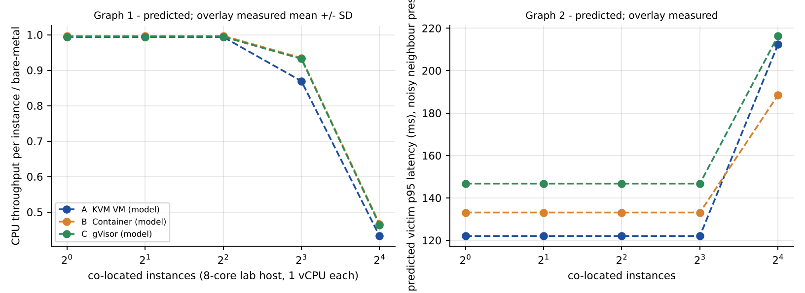
Figure 13. Graph 1 (CPU throughput per instance vs instances) and Graph 2 (victim p95 latency under noisy neighbour vs instances) - MODEL PREDICTIONS for an 8-core lab host. Replace with the measured mean +/- SD graphs from 05_analyze.py.
What to report about variability: the standard deviation across the 5 repetitions per cell (error bars in task9_graphs.png) and the coefficient of variation SD/mean. Cells with CV > 10 % deserve a comment (thermal throttling, background jobs, nested virtualization).

TASK 10 - Compare Theory with Experiment (4 marks)
Status. This section needs your measurements. I have written the predictions as testable hypotheses, the error method, and the physical reasons each kind of deviation is expected to appear; fill the yellow cells and finish the short interpretation prompts. I do not state any measured agreement here because none was measured.

10.1 Method
For every cell compare predicted P and measured M: relative error e = (P - M)/M x 100 %, using the mean of 5 repetitions and the SD as the uncertainty (a difference smaller than 2 SD is not significant). The script prints this table automatically. Trend agreement is judged by (i) the sign and rank order of degradation among A, B, C, (ii) the shape against n (flat, then ~1/rho once instances exceed cores), (iii) the position of the knee (n = cores/VCPU).

10.2 Predictions to be tested (Task 3/4 model) and error table
Table 30. Predicted versus measured (to complete).
# | Hypothesis | Predicted | Measured | Error %
H1 | CPU-bound per-instance throughput is within 1 % of bare metal for n <= cores (CPU-bound code makes few exits/syscalls) | 0.994 / 0.997 / 0.994 (A/B/C), n = 1
H2 | Beyond n = cores per-instance throughput falls as ~1/rho for all three (steal appears in A) | n = 16 on 8 cores: A 0.432, B 0.467, C 0.464
H3 | Memory-bound test shows A slowest (nested walks, +4 % overhead) and B fastest | eps_mem: A 4.2%, B 0.3%, C 2.3%
H4 | Network: once n >= 2 the NIC/loopback is the limit for A and B; gVisor needs about 2.7x the CPU per packet and stays CPU-limited longer | cores for line rate A 3.0, B 2.8, C 7.6
H5 | Disk: per-request cost C (20.3 us) > A (9.75) > B (6.3): single-instance IOPS ratio B : A : C = 1 : 0.65 : 0.31 | 317 / 205 / 99 kIOPS (EduCloud scale)
H6 | Noisy neighbour: victim degradation C > B > A (20 %, 16 %, 13 %), with B suffering from the shared kernel | 20% / 16% / 13%

10.3 Expected causes of quantitative deviation (what to look for and how large)
Table 31. Plausible reasons for model-vs-measurement differences.
Cause | Direction and size (from the model) | How to detect it
Nested virtualization (VM inside a VM on a laptop) | Exit cost rises from 1.5 us to about 10 us: A's exit overhead in the web profile goes from 1.7% to 11.0%; A looks worse than predicted, B unchanged, gVisor-KVM platform also worse | Compare A and C with B; run perf kvm stat exit counts x measured cost
SMT / hyper-threads of the laptop | If the 8 logical CPUs are 4 physical cores, per-instance throughput saturates at 4 x 1.25 = 5 core-equivalents, i.e. the knee moves from n = 8 to n = 5 | Check lscpu; repeat with smt/control = off
Turbo / thermal throttling / governor | Per-instance rate drops by 10-30 % as more cores are busy; appears equally in X, A, B, C, so use ratios to X | Compare X(n) with X(1); report CV
Caching effects | Working sets of many instances evict each other from LLC: extra loss beyond the model (kappa = 2-5 % per doubling is assumed) | Memory test and sysbench cpu with larger tables
Hypervisor / host scheduler behaviour | CFS time-slices and wake-up preemption differ from the fixed 3 ms slice assumed; p95 latency is most sensitive | Compare predicted and measured p95 rather than means
Unmodelled I/O paths | Page cache (fio with --direct=1 avoids it), loopback instead of NIC (no wire, lower c_pkt), qcow2 copy-on-write, Docker overlayfs/NAT, Gofer RPC batching | Test with raw images / host networking where possible

10.4 Which approach scales better?
Model answer to test. Because all approaches follow 1/rho once the CPU is saturated, scalability differences show up in (a) the CPU overhead per I/O and (b) the density limits. At 16 instances per 8 cores the model retains A 44 %, B 47 %, C 47 % of their one-instance throughput on a CPU-bound load; for I/O-rich loads B scales best (no per-I/O tax), A next, C worst. Write 3-4 sentences: state which approach your data show scaling best, whether its rank order matches H1-H6, and the largest discrepancy with its percentage and cause from 10.3.

10.5 Do the measurements change the Task 5 security conclusions?
- If uname -r in B equals the host kernel and in A/C differs, the shared-kernel boundary of Task 1/5 is confirmed (exposure B = 5 for T1).
- If the guest in A reports "Vulnerable"/"SMT vulnerable" lines, the exposure of A to T2 stays at 4 until the Task 7 mitigations are enabled; if the mitigations are visibly active and cost the predicted 1 point of CPU, the Task 7 trade-off holds.
- If gVisor start-up or syscall-heavy results are far worse than predicted, its practical use is limited to untrusted-code workloads; its security rank in Task 5 is unchanged but its feasibility for SIS falls.
- Write 2-3 sentences: whether any measured result changes the Task 5 ranking or the Task 6 optimum.

TASK 11 - Recommend and Defend the Final Architecture (4 marks)

11.1 Recommendation
Recommended architecture: hardware-assisted KVM virtual machines (Approach A) as the isolation boundary for the SIS, LMS and examination portal, run on dedicated host pools with SMT off and the Task 7 mitigation package; containers are used only inside the VMs as an application packaging/scaling mechanism (hybrid), and gVisor (Approach C) is reserved for untrusted-code workloads such as student code submission and autograding.
Table 32. Weighted decision matrix (scores 1-5, 5 best).
Criterion (weight) | A KVM VM | B Container | C gVisor | Evidence
Isolation strength (0.35) | 4 | 1 | 4 | I_arch 0.41 / 0.11 / 0.37 (Task 5)
Performance overhead (0.25) | 4 | 5 | 2 | eps web 1.9% / 0.4% / 7.4%; storm degradation 12% / 2% / 37%
Density (0.15) | 4 | 5 | 4 | N_max normal 60 / 62 / 61 (memory-bound); peak 44 / 46 / 43
Operations (0.15) | 3 | 4 | 3 | A: per-guest patching, image sprawl; B: immutable images, fast roll-out; C: B plus runtime to maintain
Maturity / tooling (0.10) | 5 | 5 | 3 | KVM/libvirt/OpenStack vs Docker vs younger gVisor

Weighted score: A 3.95, B 3.45, C 3.25. The ranking is not driven by 'most secure' or 'fastest': B is fastest but is excluded by the isolation constraint of Task 6 (I_min = 0.50 can never be met), C is secure but its 12.5x syscall cost leaves no headroom (eps 7.4% in normal load, 36 % in a storm) and it fails the p95 latency target at peak, and A is the only approach that satisfies both the 10 % degradation target and I_min. The weights are my judgement; with the isolation weight lowered to 0.15 (and performance raised to 0.45) B would win - the point of the Task 6 constraint is that isolation for the SIS is a requirement, not a preference.

11.2 Modelled and experimentally observed performance
Table 33. Performance evidence for the recommendation (fill the observed column from Task 9).
Metric | Modelled (SIS pool, A, SMT off) | Observed in Task 9
CPU overhead, normal web load | 1.95% (with L1D flush/KPTI: 3.05%)
Density at 3x registration peak (10 % target) | 44 VMs/host (43 with the latency target p95 <= 250 ms)
Typical case (N = 48, d = 0.5): degradation / p95 | 2.4% / 96 ms (bare metal 90 ms)
Noisy neighbour degradation | 13.5%
I/O storm degradation (the weak point) | 12.5% - above target; mitigated by admission control and SR-IOV/vhost tuning

11.3 Security posture and residual risks
After SMT off + dedicated pool, isolation score rises from 0.41 to 0.59 (>= 0.50 required). The operational threats T4-T6 are removed by process (golden images rebuilt monthly and signed, TLS migration inside the pool, no free copying of images, snapshots stored encrypted). Residual risks: LLC/memory-bus side channels that no software switch removes (T2), zero-day bugs in KVM/QEMU (T1/T3, reduced by running QEMU with seccomp/SELinux sandboxing and a minimal device model), management-plane compromise (T8; MFA, RBAC, separate admin network), insider risk. Expected exposure of A after mitigation is lowest of the three for the SIS threat mix.

11.4 Operational costs
Table 34. Operating costs.
Activity | Cost in the recommended design | Mitigation
Patching | Every VM has its own kernel (audit finding); 260+ guest kernels to patch | Immutable golden images rebuilt and rolled out by pipeline; live patching; a compliance report (kernel version per VM) blocks scheduling of outdated images
Image management | Large (GBs) images; free copying caused sprawl | Registry with signing (cosign), image expiry, quotas; containers inside VMs give small signed application layers
Migration | Pre-copy 8 GB = 10 s (20 s single-stream TLS); +7 % of the VM's vCPU during migration | Migrate inside the pool only, outside peak, TLS with multifd
Monitoring | More metrics: steal time, VM-exit rate, ballooning, p95 latency, vCPU:pCPU ratio per host | Alert on steal > 5 %, exit rate > 1 M/s per host, NIC utilisation > 70 %, memory commit > 100 %

11.5 Limitations and trade-offs
- SMT off and dedicated pools cost about 23 % of density for the SIS pool (56 -> 43 VMs/host at peak) and one to two extra hosts: this is the price of isolation.
- The model has assumed parameters (Section 0) and a simple M/M/1 latency; Task 10 quantifies the errors. In particular the 10 % target is a throughput criterion - latency is more sensitive near saturation, so I size the SIS pool with a p95 target as well.
- Memory, not CPU, bounds density (about 60 VMs/host): the most effective cost lever is right-sizing VM memory (halving demand from 8 GB to 4 GB doubles memory density) rather than switching to containers.
- Not evaluated: shared storage back-end performance, GPU workloads, Kata/Firecracker micro-VMs in practice.

11.6 Scaling from 400 to several thousand instances
Table 35. Hosts needed as EduCloud grows (A, model densities).
Instances | Production (65 %) | Research (35 %) | Pool S hosts (43 / host) | Pool R hosts (60 / host) | Total hosts | +10 % spare / N+1
400 | 260 | 140 | 7 | 3 | 10 | 11
2000 | 1300 | 700 | 31 | 12 | 43 | 48
4000 | 2600 | 1400 | 61 | 24 | 85 | 94
8000 | 5200 | 2800 | 121 | 47 | 168 | 185

The design remains practical: host count grows linearly (about 85 hosts for 4000 instances), the pool structure scales by adding hosts to a pool, and the control plane should be partitioned into cells of roughly 100-200 hosts (OpenStack cells or one libvirt/Kubernetes-on-KubeVirt cluster per pool). What does not scale is manual per-VM patching and manual image copying, which is why pipeline-driven immutable images and signing are part of the recommendation. If services were redesigned to need only 2 GB, per-host memory density would rise to 220 (A) / 249 (B), CPU would become the limit, and containers inside the VMs would then give a real density benefit while the VM boundary stays.

TASK 12 - Day-4 Design Challenge: Re-evaluate and Adapt the Design (8 marks)

A. Impact Analysis (2 marks)
Table 36. Assumptions that no longer hold.
Original assumption | New condition | Consequence
All tenants trusted (university departments) | External collaborators run arbitrary Spark/Hadoop code | Attacker model changes from "mistake" to "malicious co-tenant": T1/T2/T3 become likely, not theoretical
Workload mix: web + DB, latency-sensitive, d = 0.25 | Add I/O- and network-intensive batch jobs running for hours (per executor: 8 vCPU, 32 GB, about 3 Gbit/s shuffle, 50 k IOPS) | Sustained load, not bursts: no idle periods in which the scheduler can give capacity back
Average SIS network 0.2 Gbit/s per VM; peak 3x | Registration peak 3x coincides with batch jobs | NIC and memory bandwidth become the shared bottleneck, not CPU
Patching by live migration is safe | Migrating running VMs that include external tenants | Migration traffic (9.6 Gbit/s) and RAM contents of regulated and external VMs share the network
Isolation is best effort | Regulation requires demonstrable isolation of student records from external tenants | Isolation becomes a hard constraint verifiable by audit

Performance effect of mixing. (1) Network: at the 3x peak the SIS VMs alone offer 30 x 0.6 = 18 Gbit/s to a port with 23.5 Gbit/s usable (u = 0.76); adding only 4 Spark executors (12 Gbit/s) gives 30 Gbit/s, u = 1.27 - the port is saturated, and a live migration (9.6 Gbit/s) pushes it to u = 1.68. For a queue the delay grows as 1/(1 - u): 4x at u = 0.76, unbounded beyond 1 - logins fail and time out. (2) CPU: demand on a mixed host is 30 SIS VMs x 2 x 0.75 + 4 executors x 8 x 0.8 = 70.6 cores versus 78 available (SMT on): no steal on average, but the executors never idle, so SIS vCPUs lose all opportunistic capacity. (3) Memory bandwidth/LLC: Spark scans and shuffles use a large share of memory bandwidth (the u = 30 % assumed in Task 4 for a noisy neighbour becomes continuous), giving each SIS VM the 13 % (A) or 16 % (B) penalty permanently instead of sporadically. (4) Migration: an executor with 32 GB and a high dirty rate takes 40 s to migrate at a 3.2 Gbit/s dirty rate and 160 s at 8 Gbit/s (downtime 4.7 s), longer than the registration peak, and heavily dirtying JVM heaps may never converge.
Effect on the threat model. The isolation score of the original design (shared hosts, SMT on) was 0.41 against trusted tenants; against an untrusted co-tenant on the same host (T1, T2, T3 each one step worse) it falls to 0.28, well under the SIS requirement of 0.50. T2 (side channels) and T7 (network spoofing from a tenant-controlled VM) are now the main routes to student records; T6 (migration) matters more because RAM of regulated VMs could be exposed to an external tenant's network segment; T4 (unpatched guests) is worse because external collaborators control their own guest software.
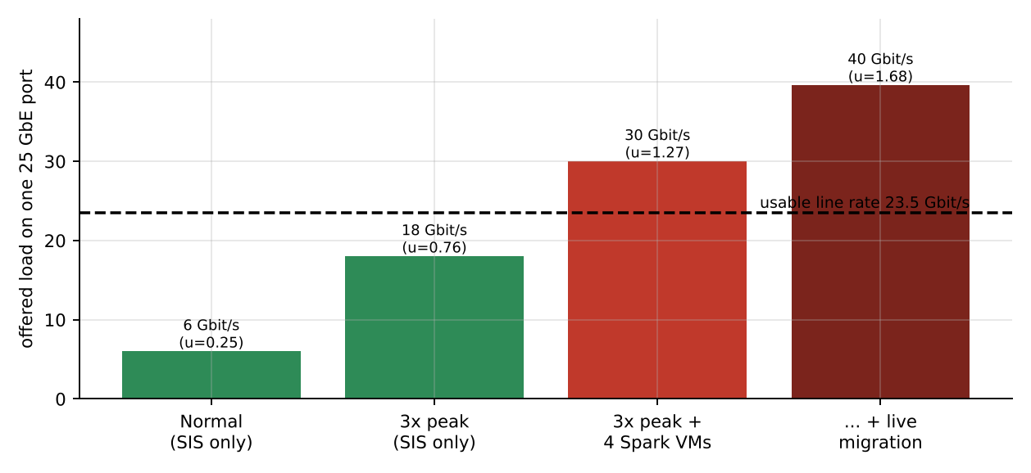
Figure 14. Offered load on one 25 GbE port as the Spark executors and a live migration are added to the 3x registration peak.

B. Evaluation of the Original Design (2 marks)
The "original design" is the Task 11 recommendation applied naively: KVM VMs on the shared 16-host pool, SMT on, Spark VMs added to the same hosts.
Table 37. Original design versus the new requirements.
Requirement | Model result with new workload | Met?
CPU degradation <= 10 % at peak | SIS-only host, 30 VMs, SMT on, d = 0.75: p95 195 ms, no steal. Mixed host: demand 71 of 78 cores - CPU alone is still within target | Yes (CPU)
Network capacity for SIS at peak plus Spark | u = 1.27 (> 1) on a mixed host; 1.68 with migration. Spark needs 0.39 cores per executor just for packets (A); 0.97 for gVisor | NO
Isolation I >= 0.50 for SIS against external tenants | I = 0.28 (shared host, SMT on, untrusted co-tenant) | NO
Demonstrable isolation (regulation) | Co-residence of SIS and external VMs on the same host, shared vSwitch/VLAN, shared migration network - cannot be shown to auditors | NO

Could another architecture do better overall? (i) Containers (B): best throughput (0.5% overhead for the Spark profile) but I never exceeds 0.28 even with a dedicated pool and SMT off, so they cannot protect student records from external code - rejected. (ii) gVisor (C): isolation is adequate (I = 0.55 dedicated, SMT off), but for the Spark profile (6x10^4 syscalls/s per vCPU) its overhead is 15.1%, above the 10 % target, and it needs 0.97 cores per executor for the network - infeasible for hours-long I/O-bound jobs. It remains suitable for small untrusted jobs. (iii) KVM micro-VMs (Kata/Firecracker): same hardware boundary as A with a minimal device model (smaller T3 surface) and fast start-up; their cost model is that of A, so they would add operational complexity without changing density - a sensible later step for the external pool, not required now. Conclusion: the isolation layer should stay VM-based, but tenancy, host pools and the I/O path must change - Approach A is retained as the technology, the deployment is modified.

C. Adaptation or Redesign (2 marks)
Decision: MODIFY (retain KVM VMs, redesign tenant placement and the data-intensive I/O path).
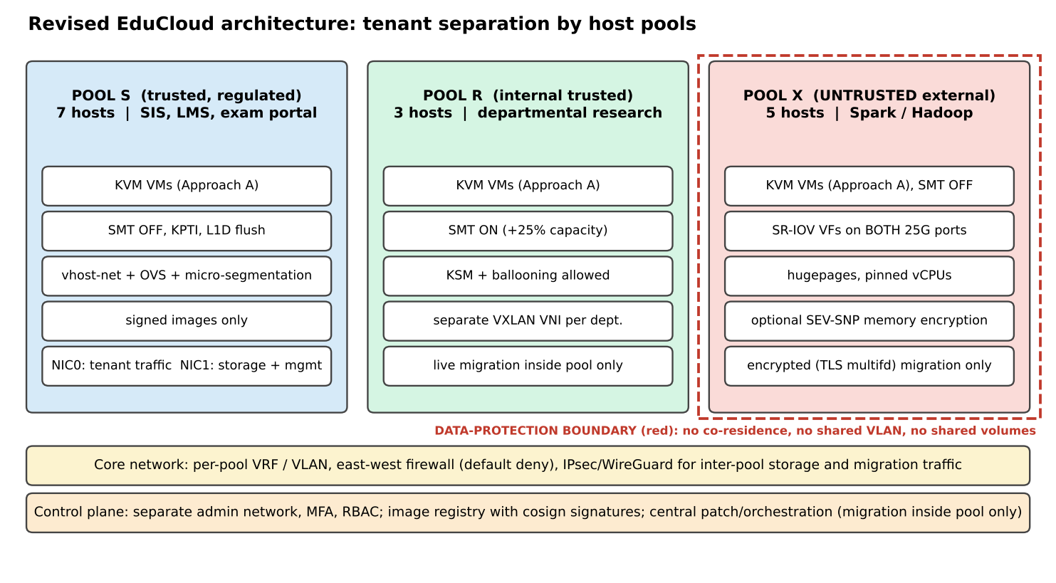
Figure 15. Revised EduCloud architecture: three host pools separated by trust level and workload type.
Table 38. Pool design and sizing with the Task 3 model.
Pool | Tenants | Technology and settings | Per-host density | Hosts
S (regulated) | 260 SIS, LMS, exam VMs (3x peak) | KVM, SMT off, L1D flush/KPTI, vhost-net + OVS, micro-segmentation, signed images, encrypted migration inside pool, no external tenants | 43 VMs (p95 <= 250 ms at peak; CPU target alone allows 44) | 7
R (internal research) | 140 departmental VMs, d = 0.6 | KVM, SMT on (+25 %), KSM/ballooning allowed, separate VXLAN per department | 60 VMs (memory limit) | 3
X (external) | 48 Spark/Hadoop executors (8 vCPU, 32 GB, 3 Gbit/s) | KVM, SMT off, hugepages, pinned vCPUs, SR-IOV VFs on both 25 G ports, optional SEV-SNP memory encryption, local encrypted NVMe, no live migration (drain-and-patch) | 10 executors (CPU 10, memory 15, network 15 with 2 ports; only 7 with one) | 5 (vs 7 with one port)
Total |  |  |  | 15 of 16 hosts

What changes and its effect:
Table 39. Effect of the adaptation on density, throughput and attack surface.
Aspect | Before | After | Effect
Density (SIS pool) | 56 VMs/host (SMT on, no mitigations) | 43 VMs/host (SMT off, mitigations, latency target) | -23 %: SIS pool needs 7 hosts instead of 5
Throughput (Spark) | 7 executors per NIC, u > 1 when shared with SIS | 10 executors per host, each with a 3 Gbit/s dedicated VF path; host vSwitch bypassed (the 0.39 cores per executor otherwise spent on vhost/OVS packet work shrink to hardware DMA) | SIS network no longer shares a port with shuffle traffic; the NIC stops being the bottleneck
Attack surface | I = 0.28 against external co-tenant | I(SIS) = 0.59; no co-residence, no shared VLAN, SIS migration network separate | T1/T2/T3 from external tenants removed from SIS hosts; T7 limited to Pool X; auditors can verify pools by inventory
Live migration / patching | Live-migrate anything, unencrypted | Pools S, R: TLS multifd migration (10 s for 8 GB) outside peak; Pool X: drain executors and reboot (Spark tolerates restarts) | No RAM of regulated VMs ever crosses a network shared with external tenants
Cost | 16 hosts, consolidated | 15 hosts in three pools (1 spare) | Compliance costs about +4 hosts compared with the consolidated non-compliant layout (11 by the CPU/memory model)

SR-IOV has trade-offs that I accept for Pool X only: VFs bypass the host virtual switch (so host-side firewalling/micro-segmentation is lost - compensated by the dedicated pool and an external top-of-rack ACL) and make live migration impractical (hence drain-and-patch).

D. Evidence-Based Defence (2 marks)
Table 40. Options compared with the model.
Option | Hosts | I for SIS | Feasible | Remark
Retain: A, shared 16 hosts, SMT on | ~11 (CPU/memory model) | 0.28 | No | NIC u > 1, non-compliant
Modify: A in pools S/R/X, SR-IOV for X (chosen) | 15 | 0.59 | Yes | NIC stops being a bottleneck; +4 hosts
Redesign: containers (B) in pools | ~14 | 0.28 | No | Isolation constraint fails
Redesign: gVisor (C) everywhere | Spark pool infeasible at 10 % target | 0.55 | Partly | eps(Spark) 15.1%; 0.97 cores/executor for packets
Redesign: Kata/Firecracker for Pool X | same as chosen | 0.59 | Yes | Extra operational complexity, no density gain

Model evidence. (1) The Task 3 network model shows the port, not the CPU, fails when Spark joins the SIS (u = 1.27); dedicating NIC ports through SR-IOV in an isolated pool removes the contention instead of tuning around it. (2) The Task 6 formulation with the new constraint z_SIS = z_EXT = 1 makes pooling mandatory; the minimum-cost feasible configuration for the SIS is A, dedicated, SMT off (Z = 22.5). (3) Task 7 quantified the price: SMT off about -20 % capacity, L1D flush/KPTI about +1 point CPU, micro-segmentation +10 % per-packet cost - together 7 instead of 5 hosts for the SIS, which the 16-host budget can absorb (15 used).
Experimental evidence (to be completed with Task 9 data). The noisy-neighbour experiment is the key test: the model predicts a 13% victim degradation for A, 16% for B, 20% for C even when CPU is not overcommitted, which shows that interference through hardware (memory bandwidth, LLC) cannot be removed by choosing a different virtualization approach - only by separating tenants on different hosts. That supports the pool decision regardless of the exact measured values: insert your measured noisy-neighbour degradations and state whether they confirm that the ranking of Approach A versus B matches H6. The mitigation experiment (SMT on/off, L1D flush/KPTI) gives the measured cost to compare with the 20 % and 1-point predictions: insert measured values; if the measured SMT cost is larger than 20 %, Pool S needs about one more host (7 -> 8) and the total would be 16, still within budget.
Decision logic and its limits. The decision follows from three independent findings: (i) isolation against external tenants requires hardware-enforced separation and, under the regulation, host-level separation (Tasks 5, 6); (ii) VM-based isolation is the only option that satisfies both the isolation and the 10 % degradation constraints for Spark-like I/O (this task, B/C); (iii) the NIC, not CPU, is the shared bottleneck, so the I/O path of the external pool must be decoupled (SR-IOV, dual ports). The cost is 4 additional hosts relative to a non-compliant consolidated layout and a 23 % lower density for the SIS pool. If the budget does not allow this, the fallback is to run external workloads only in Pool X with fewer executors (e.g. 30 instead of 48) rather than relaxing isolation. Limitations: results depend on the assumed Spark profile, memory-bandwidth contention is modelled as a simple queueing factor, and a hardware vulnerability that crosses hosts (e.g. a firmware bug) is outside the model.

APPENDIX A - Analytical model source code
educloud_model.py implements every formula of Tasks 2-4, 7 and 12 (parameters at the top); results.py evaluates the scenarios, the Task 5 scores, the Task 6 enumeration and the Task 7 mitigations. Run python3 results.py to print all numbers used in this report.

A.1 educloud_model.py
"""
EduCloud analytical model (Cloud Computing & Big Data - Assignment 2)
Approaches: A = KVM VM (Type-1, hardware-assisted full virtualization, virtio/vhost)
B = OS-level containers (Docker/runc: namespaces + cgroups)
C = Sandboxed container runtime (gVisor/runsc, KVM platform)
All time units are seconds unless the name ends in _us.
"""
import math

# ------------------------------------------------------------------ given parameters
C = 64 # physical cores / host
R = 512.0 # GB RAM / host
m = 8.0 # GB average VM memory demand
T_EXIT = 1.5e-6 # s, one VM exit (given)
T_SYS = 0.2e-6 # s, native system call (given)
L = 25e9 # b/s line rate (given)
OVERCOMMIT = [1, 2, 4, 8]

# ------------------------------------------------------------------ stated assumptions
V = 2 # vCPUs (or CPU quota) per instance
H = {'A': 2, 'B': 1, 'C': 1} # host cores reserved for hypervisor / host OS / daemons
RH = {'A': 16, 'B': 8, 'C': 12} # GB host RAM reserved
OMEM = {'A': 0.25, 'B': 0.02, 'C': 0.08} # GB per-instance overhead (QEMU proc + EPT tables / shim / Sentry+Gofer)
SIGMA = 0.15 # fraction of VM memory shareable by KSM (same guest OS image)
BETA = 0.25 # fraction of guest memory reclaimable by ballooning
SLO = 0.10 # max performance degradation vs. bare metal

T_WALK = 0.10e-6 # extra cost of a 2-D (nested) page walk per TLB miss
T_SEC = 0.03e-6 # seccomp + namespace overhead per syscall (containers)
T_SENTRY= 1.0e-6 # gVisor Sentry handling per syscall (in addition to the trap)
T_GV = T_EXIT + T_SENTRY # = 2.5 us per intercepted syscall (KVM platform)
R_BASE = 1000 # exits/s/vCPU from timer, IPI, HLT (idle/tick)
X_IO = 0.5 # exits per I/O op after virtio batching / event-idx / posted interrupts
TAU = 3e-3 # scheduler time-slice
CSW0, CSW1 = 10e-6, 5e-6 # VM/vCPU switch cost = CSW0 + CSW1*(rho-1) (cache/TLB refill)
CSW_B = 3e-6 # container context switch
CG_FIX = 0.003 # cgroup accounting fixed CPU overhead (containers)

PROFILES = { # per busy vCPU-second
'cpu': dict(d=1.0, r_sys=100, r_io=0, mu=5e4),
'mem': dict(d=1.0, r_sys=100, r_io=0, mu=4e5),
'web': dict(d=0.25, r_sys=3e4, r_io=2e4, mu=3e4), # SIS / LMS normal load (peak = 3x -> d=0.75)
'storm': dict(d=1.0, r_sys=1.5e5, r_io=1e5, mu=2e5),
}

# ------------------------------------------------------------------ CPU
def eps_parts(a, rho, prof, t_exit=T_EXIT, t_sys=T_SYS, extra_sys=0.0):
p = PROFILES[prof] if isinstance(prof, str) else prof
sched = 0.0
if rho > 1:
csw = (CSW0 + CSW1 * (rho - 1)) if a != 'B' else CSW_B
sched = csw / TAU
if a == 'A':
exits = R_BASE + p['r_io'] * X_IO
return dict(exit=exits * t_exit, ept=p['mu'] * T_WALK, sched=sched, sys=extra_sys * p['r_sys'])
if a == 'B':
return dict(cg=CG_FIX, sys=p['r_sys'] * (T_SEC + extra_sys), sched=sched)
if a == 'C':
t_gv = t_exit + T_SENTRY
return dict(sys=p['r_sys'] * (t_gv - t_sys + extra_sys), ept=p['mu'] * T_WALK * 0.5,
sched=sched, cg=CG_FIX)

def eps(a, rho, prof, **kw):
return sum(eps_parts(a, rho, prof, **kw).values())

def share(a, N, d, cap=None):
"""fraction of demand the host can supply when N instances of V vCPUs and duty cycle d are co-located"""
cores = (C if cap is None else cap) - H[a]
return min(1.0, cores / (N * V * d))

def per_vm_capacity(a, rho, prof='cpu', cap=None):
"""useful pCPU-equivalents delivered to one instance (V vCPUs) at overcommit rho (vCPU:pCPU)"""
p = PROFILES[prof]
N = rho * C / V
f = share(a, N, p['d'], cap)
e = eps(a, rho, prof)
return V * p['d'] * f * (1 - e), (1 - f), e # capacity, steal fraction, overhead

def degradation(a, N, prof='web', d=None, cap=None, **kw):
p = dict(PROFILES[prof])
if d is not None: p['d'] = d
rho = N * V / C
f = share(a, N, p['d'], cap)
e = eps(a, rho, p, **kw)
return 1 - (1 - e) * f, e, 1 - f

def n_cpu_slo(a, prof='web', d=None, cap=None, **kw):
best = 0
for N in range(1, 600):
D, *_ = degradation(a, N, prof, d, cap, **kw)
if D <= SLO: best = N
return best

# ------------------------------------------------------------------ memory
def n_mem(a, ksm=False, balloon=False, m_=m):
per = m_ * ((1 - SIGMA) if (ksm and a == 'A') else 1) + OMEM[a]
n = math.floor((R - RH[a]) / per)
if balloon: n = math.floor((R - RH[a]) / ((m_ * (1 - BETA)) + OMEM[a]))
return n

def eat(p_fault, t_mem=100e-9, t_swap=80e-6):
return (1 - p_fault) * t_mem + p_fault * t_swap

# ------------------------------------------------------------------ network / disk
PKT_BITS = 1500 * 8
ETA = 1448 / 1538 # TCP goodput efficiency at MTU 1500
L_EFF = L * ETA
B_BATCH = 16 # packets per exit (virtio event-idx / NAPI)
IOPS_DEV = 600e3 # 4 KiB random-read IOPS of the host NVMe (assumption)
KAPPA = {'A': 0.02, 'B': 0.02, 'C': 0.05} # per-doubling cache/lock contention

def c_pkt(a, n=1, t_exit=T_EXIT, extra=0.0):
if a == 'A': return 0.80e-6 + 0.35e-6 + t_exit / B_BATCH + 0.30e-6 + extra
if a == 'B': return 0.80e-6 + 0.25e-6 + (0.20e-6 + 0.01e-6 * n) + extra
if a == 'C': return 0.80e-6 + 2.50e-6 + (T_GV - T_SYS) / 4 + extra

def c_io(a, t_exit=T_EXIT):
if a == 'A': return 6e-6 + 2 * t_exit / 4 + 3e-6 # submit/complete + exits per batch of 4 + QEMU iothread
if a == 'B': return 6.3e-6
if a == 'C': return 6e-6 + (T_GV - T_SYS) + 12e-6 # + gofer RPC

def net_per_instance(a, n, extra=0.0, t_exit=T_EXIT, line=None):
line = L_EFF if line is None else line
c = c_pkt(a, n, t_exit, extra) * (1 + KAPPA[a] * math.log2(max(n, 1)))
cores = min(n * V, C - H[a])
pps = min(line / PKT_BITS, cores / c)
return pps * PKT_BITS / n / 1e9 # Gbps / instance

def disk_per_instance(a, n, t_exit=T_EXIT):
c = c_io(a, t_exit) * (1 + KAPPA[a] * math.log2(max(n, 1)))
cores = min(n * V, C - H[a])
return min(IOPS_DEV, cores / c) / n / 1e3 # kIOPS / instance

def cores_for_line(a, n=16, gbps=None):
gbps = L_EFF / 1e9 if gbps is None else gbps
return gbps * 1e9 / PKT_BITS * c_pkt(a, n)

# ------------------------------------------------------------------ latency (M/M/1 per vCPU + wake-up delay)
S0 = 15e-3
def latency(a, N, d=0.25, prof='web', cap=None, **kw):
p = dict(PROFILES[prof]); p['d'] = d
rho = N * V / C
f = share(a, N, d, cap)
e = eps(a, rho, p, **kw)
S = S0 / ((1 - e) * f)
U = d / ((1 - e) * f)
if U >= 0.995: return float('inf'), float('inf')
W = S / (1 - U)
uh = min(1, rho * d)
dl = TAU * uh * (1 - 1 / max(rho, 1)) if a != 'B' else TAU * uh * (1 - 1 / max(rho, 1)) * 0.8
return (W + dl) * 1e3, (3 * W + 2 * dl) * 1e3 # mean, p95 (ms)

# ------------------------------------------------------------------ live migration (pre-copy)
def migration(M_gb=8.0, bw_gbps=9.6, dirty_gbps=3.2, enc_cores_gbps=6.4, encrypted=False):
B = bw_gbps; r = dirty_gbps
if encrypted: B = min(B, enc_cores_gbps)
if r >= B: return float('inf'), float('inf')
t = (M_gb * 8 / B) / (1 - r / B)
down = 0.3 * (M_gb * 8 / B) * (r / B) ** 3 + 0.05
return t, down

if __name__ == '__main__':
for a in 'ABC':
print(a, 'n_mem', n_mem(a), 'ksm', n_mem(a, True), 'balloon', n_mem(a, balloon=True),
'N_cpu web', n_cpu_slo(a), 'eps web', round(eps(a, 1, 'web') * 100, 2),
'cores@line', round(cores_for_line(a), 2))

A.2 results.py
import math, itertools
import educloud_model as M
from educloud_model import *

R = {}
SMT_GAIN = 1.25
CAP_SMT_ON, CAP_SMT_OFF = 64*SMT_GAIN, 64.0

# ---------- Task 3 summaries
R['n_mem'] = {a: n_mem(a) for a in 'ABC'}
R['n_mem_ksm']={a: n_mem(a, ksm=True) for a in 'ABC'}
R['n_mem_bal']={a: n_mem(a, balloon=True) for a in 'ABC'}
R['eps_web'] = {a: eps_parts(a,1,'web') for a in 'ABC'}
R['eps_storm']={a: eps_parts(a,1,'storm') for a in 'ABC'}
R['eps_mem'] = {a: eps_parts(a,1,'mem') for a in 'ABC'}
R['eps_cpu'] = {a: eps_parts(a,1,'cpu') for a in 'ABC'}
R['cap_cpu'] = {a: [per_vm_capacity(a,r,'cpu') for r in OVERCOMMIT] for a in 'ABC'}
R['cap_web'] = {a: [per_vm_capacity(a,r,'web') for r in OVERCOMMIT] for a in 'ABC'}
R['ncpu_web'] = {a: n_cpu_slo(a,'web') for a in 'ABC'} # d=0.4
PEAK=0.75
R['ncpu_peak'] = {a: n_cpu_slo(a,'web',d=PEAK) for a in 'ABC'} # 3x registration peak
R['ncpu_peak_smt']={a: n_cpu_slo(a,'web',d=PEAK,cap=CAP_SMT_ON) for a in 'ABC'}
R['nnet_per_inst'] = 0.2 # Gbps average SIS/LMS VM
R['n_net_web'] = math.floor(L_EFF/1e9/R['nnet_per_inst'])
R['dens_web'] = {a: min(R['ncpu_web'][a], R['n_mem'][a], R['n_net_web']) for a in 'ABC'}
R['dens_peak'] = {a: min(R['ncpu_peak'][a], R['n_mem'][a], R['n_net_web']) for a in 'ABC'}
R['net_n'] = {a: [net_per_instance(a,n) for n in (1,2,4,8,16)] for a in 'ABC'}
R['disk_n']= {a: [disk_per_instance(a,n) for n in (1,2,4,8,16)] for a in 'ABC'}
R['cores_line'] = {a: cores_for_line(a) for a in 'ABC'}
R['c_pkt'] = {a: c_pkt(a,16)*1e6 for a in 'ABC'}
R['c_io'] = {a: c_io(a)*1e6 for a in 'ABC'}

# ---------- Task 4 scenarios
sc = {}
hp = dict(d=0.25, r_sys=3e4, r_io=2e4, mu=3e3) # best case: 2 MiB/1 GiB huge pages, pinned vCPUs
for a in 'ABC':
# best: N=16 instances, pinned, huge pages, no contention
e_best = eps(a,1,hp)
lat_b = latency(a,16)
# typical: N=48, d=0.5
D_t,e_t,st_t = degradation(a,48,'web',d=0.5)
lat_t = latency(a,48,d=0.5)
# worst-1: noisy neighbour (membw u=0.3, victim memory-bound fraction 0.3, shared-kernel penalty)
kk = {'A':0.0,'B':0.06,'C':0.02}[a]
u=0.3; phi=0.3
slow = 1 + phi*(1/(1-u)-1) + kk
D_t0,e_n,_ = degradation(a,48,'web',d=0.5)
D_nn = 1 - (1-e_n)/slow
# worst-2: memory overcommit swapping (p_fault 1e-3, blind-paging factor)
pf = {'A':1.5e-3,'B':1.0e-3,'C':1.3e-3}[a]
slow_sw = 1 + phi*(eat(pf)/100e-9 - 1)
D_sw = 1 - (1-e_n)/slow_sw
# worst-3: I/O storm at N=32
D_st,e_st,st_st = degradation(a,32,'storm')
# worst-4: live migration of one 8 GB VM, 3.2 Gb/s dirty rate, 9.6 Gb/s migration bandwidth
sc[a] = dict(e_best=e_best, lat_best=lat_b, D_typ=D_t, e_typ=e_t, lat_typ=lat_t,
slow_nn=slow, D_nn=D_nn, pf=pf, slow_sw=slow_sw, D_sw=D_sw, D_storm=D_st, e_storm=e_st, steal_storm=st_st,
eat_ns=eat(pf)*1e9)
R['sc'] = sc
R['mig'] = dict(plain=migration(), enc=migration(encrypted=True), enc_multifd=migration(encrypted=True, enc_cores_gbps=19.2),
heavy=migration(dirty_gbps=8.0))
R['mig_dirty_exits'] = (3.2e9/8/4096)*T_EXIT/V # fraction of the VM's 2 vCPUs lost to write-protect faults
R['mig_freeze'] = 8*8/9.6 # containers: stop-the-world checkpoint of 8 GB at 9.6 Gb/s

# ---------- Task 5 security matrix
threats = ['T1 Isolation-boundary escape','T2 Cross-tenant side channels','T3 Hypervisor / runtime / kernel vulnerability',
'T4 VM sprawl & unpatched guests','T5 Image tampering / uncontrolled copies','T6 Insecure live migration / checkpoint',
'T7 Virtual-network sniffing & spoofing','T8 Management-plane compromise']
exp = {'A':[2,4,3,5,4,4,3,3], 'B':[5,5,4,3,2,1,4,4], 'C':[2,4,3,3,2,2,3,4]}
w = [.18,.14,.14,.14,.08,.10,.08,.14]
arch = [0,1,2,6,7]; ops=[3,4,5]
def index(a, idx, adj=None):
e = list(exp[a])
if adj:
for i,dv in adj.items(): e[i] = max(1, e[i]+dv)
ws = sum(w[i] for i in idx)
return sum(w[i]*e[i] for i in idx)/ws/5
R['threats']=threats; R['exp']=exp; R['w']=w
R['E_arch']={a:index(a,arch) for a in 'ABC'}; R['E_ops']={a:index(a,ops) for a in 'ABC'}
R['I_arch']={a:1-R['E_arch'][a] for a in 'ABC'}
def I_iso(a, smt_off, dedicated):
adj={}
if smt_off: adj[1]=adj.get(1,0)-1
if dedicated:
for i in (0,1,2): adj[i]=adj.get(i,0)-1
return 1-index(a,arch,adj)
R['I_opts']={(a,s,d):I_iso(a,s,d) for a in 'ABC' for s in (0,1) for d in (0,1)}

# ---------- Task 6 enumeration for the SIS class (260 instances)
N_SIS, LAMBDA = 260, 40.0
I_MIN = 0.50
opts=[]
for a in 'ABC':
for smt_off in (0,1):
for ded in (0,1):
cap = CAP_SMT_OFF if smt_off else CAP_SMT_ON
n_cpu = n_cpu_slo(a,'web',d=PEAK,cap=cap)
n_ = min(n_cpu, n_mem(a))
hosts = math.ceil(N_SIS/n_) if n_>0 else 999
I = I_iso(a,smt_off,ded)
# shared pools: hosts are shared with other tenants -> stranded capacity factor 1.0; dedicated: no sharing gain (already counted as dedicated pool)
Z = hosts + LAMBDA*(1-I)
ok = I>=I_MIN
opts.append(dict(a=a,smt_off=smt_off,ded=ded,n=n_,hosts=hosts,I=I,Z=Z,ok=ok))
R['opts']=opts; R['I_MIN']=I_MIN; R['LAMBDA']=LAMBDA; R['N_SIS']=N_SIS

# ---------- Task 7 mitigations (A, SIS peak d=1.0 unless noted)
mit={}
base_cap = CAP_SMT_ON
n0 = n_cpu_slo('A','web',d=PEAK,cap=base_cap)
mit['smt'] = dict(n_before=n0, n_after=n_cpu_slo('A','web',d=PEAK,cap=CAP_SMT_OFF),
nB_before=n_cpu_slo('B','web',d=PEAK,cap=base_cap), nB_after=n_cpu_slo('B','web',d=PEAK,cap=CAP_SMT_OFF))
# L1D flush on VM entry: +1.0 us per exit ; KPTI: +0.15 us per syscall
mit['l1d'] = dict(eps_before=eps('A',1,'web'), eps_after=eps('A',1,'web',t_exit=T_EXIT+1.0e-6),
n_before=n_cpu_slo('A','web',d=PEAK), n_after=n_cpu_slo('A','web',d=PEAK,t_exit=T_EXIT+1.0e-6),
storm_before=eps('A',1,'storm'), storm_after=eps('A',1,'storm',t_exit=T_EXIT+1.0e-6),
pkt_before=c_pkt('A',16)*1e6, pkt_after=c_pkt('A',16,t_exit=T_EXIT+1.0e-6)*1e6)
mit['kpti']= dict(epsB_before=eps('B',1,'web'), epsB_after=eps('B',1,'web',extra_sys=0.15e-6),
epsC_before=eps('C',1,'web'), epsC_after=eps('C',1,'web',extra_sys=0.15e-6),
epsA_after=eps('A',1,'web',extra_sys=0.15e-6))
# dedicated hosts for SIS pool vs consolidated shared pool (peak d=1.0, mixed fleet 400 VMs)
_cap_eff = (CAP_SMT_ON - M.H['A'])*(1-0.02)/0.9
_dem = 260*2*PEAK + 140*2*0.6
mit['ded'] = dict(shared_hosts=max(math.ceil(_dem/_cap_eff), math.ceil(400/n_mem('A'))),
sis_hosts=math.ceil(260/min(n_cpu_slo('A','web',d=PEAK,cap=CAP_SMT_OFF), n_mem('A'))),
res_hosts=math.ceil(140/min(n_cpu_slo('A','web',d=0.6,cap=CAP_SMT_ON), n_mem('A'))),
dem=_dem, cap_eff=_cap_eff)
# sandboxed runtime: B -> C ; secure container, same app
mit['sandbox'] = dict(epsB=eps('B',1,'web'), epsC=eps('C',1,'web'), epsB_storm=eps('B',1,'storm'), epsC_storm=eps('C',1,'storm'),
coresB=cores_for_line('B'), coresC=cores_for_line('C'),
nB=n_cpu_slo('B','web',d=PEAK), nC=n_cpu_slo('C','web',d=PEAK))
# memory encryption (SEV-SNP / TDX): +3% on memory-bound portion, KSM lost, +0.1 GB/VM metadata
mit['memenc'] = dict(n_ksm=n_mem('A',ksm=True), n_plain=n_mem('A'),
n_enc=math.floor((R_:=M.R-M.RH['A'])/(M.m+M.OMEM['A']+0.1)), eps_add=0.03*0.3)
# micro-segmentation (distributed firewall)
mit['seg'] = dict(c_before=c_pkt('A',16)*1e6, c_after=c_pkt('A',16,extra=0.15e-6)*1e6,
cores_before=cores_for_line('A'), cores_after=L_EFF/PKT_BITS*c_pkt('A',16,extra=0.15e-6)*(1+KAPPA['A']*math.log2(16))/(1+KAPPA['A']*math.log2(16)))
mit['seg']['pct']=(mit['seg']['c_after']/mit['seg']['c_before']-1)*100
R['mit']=mit

# ---------- Task 12
t12={}
# per-host SIS co-hosting with Spark VMs on shared hosts (original design under new workload)
sis_n, sp_n = 30, 4
sis_net_peak = 0.2*3 # Gbps / SIS VM at 3x peak
sp_net = 3.0
nic_load = sis_n*sis_net_peak + sp_n*sp_net
t12['nic_load']=nic_load; t12['nic_u']=nic_load/(L_EFF/1e9)
t12['nic_u_sis_only']=sis_n*sis_net_peak/(L_EFF/1e9)
t12['mig_gbps']=9.6
t12['nic_u_with_mig']=(nic_load+9.6)/(L_EFF/1e9)
# CPU on the mixed host: 30 SIS (v=2,d=1.0 peak) + 4 Spark (v=8,d=0.8)
cpu_dem = sis_n*2*PEAK + sp_n*8*0.8
t12['cpu_dem']=cpu_dem; t12['cpu_cap']=CAP_SMT_ON-M.H['A']
t12['f_mixed']=min(1,(CAP_SMT_ON-M.H['A'])/cpu_dem)
t12['sis_only_dem']=sis_n*2*PEAK
t12['lat_orig_peak']=latency('A',30,d=PEAK,cap=CAP_SMT_ON)
# redesigned pools
nS = min(n_cpu_slo('A','web',d=PEAK,cap=CAP_SMT_OFF), n_mem('A'))
nR = min(n_cpu_slo('A','web',d=0.6,cap=CAP_SMT_ON), n_mem('A'))
M.V=8
n_cpu_X = n_cpu_slo('A','web',d=0.8,cap=CAP_SMT_OFF)
n_mem_X = n_mem('A', m_=32.0)
M.V=2
n_net_1 = math.floor(L_EFF/1e9/3.0); n_net_2 = math.floor(2*L_EFF/1e9/3.0)
t12.update(nS=nS,nR=nR,n_cpu_X=n_cpu_X,n_mem_X=n_mem_X,n_net_1=n_net_1,n_net_2=n_net_2)
nX_single = min(n_cpu_X,n_mem_X,n_net_1); nX_dual = min(n_cpu_X,n_mem_X,n_net_2)
t12.update(nX_single=nX_single,nX_dual=nX_dual)
t12['HS']=math.ceil(260/nS); t12['HR']=math.ceil(140/nR)
t12['EXEC']=48
t12['HX_single']=math.ceil(48/nX_single); t12['HX_dual']=math.ceil(48/nX_dual)
t12['total_dual']=t12['HS']+t12['HR']+t12['HX_dual']; t12['total_single']=t12['HS']+t12['HR']+t12['HX_single']
t12['cores_spark_net_A']=3.0e9/PKT_BITS*c_pkt('A',8)
t12['cores_spark_net_C']=3.0e9/PKT_BITS*c_pkt('C',8)
t12['lat_sis_peak_new']=latency('A',nS,d=PEAK,cap=CAP_SMT_OFF)
t12['D_sis_new']=degradation('A',nS,'web',d=PEAK,cap=CAP_SMT_OFF)
t12['mig_enc']=migration(encrypted=True); t12['mig_enc_mf']=migration(encrypted=True,enc_cores_gbps=19.2)
t12['I_before']=I_iso('A',0,0); t12['I_after_sis']=I_iso('A',1,1); t12['I_B_after']=I_iso('B',1,1)
R['t12']=t12

if __name__=='__main__':
import pprint; pprint.pprint(R, width=140, compact=True)

# ---- latency-based sizing at registration peak (p95 <= 250 ms) -- used in Task 11/12
def n_lat_slo(a, d=PEAK, p95=250.0, cap=CAP_SMT_OFF):
best=0
for N in range(1,200):
if latency(a,N,d=d,cap=cap)[1] <= p95: best=N
return best
R['n_lat_peak'] = {a: n_lat_slo(a) for a in 'ABC'}
R['n_lat_peak_smt'] = {a: n_lat_slo(a,cap=CAP_SMT_ON) for a in 'ABC'}
R['t12']['nS_lat'] = min(R['n_lat_peak']['A'], n_mem('A'))
R['t12']['HS_lat'] = math.ceil(260/R['t12']['nS_lat'])
R['t12']['total_dual_lat'] = R['t12']['HS_lat']+R['t12']['HR']+R['t12']['HX_dual']
R['t12']['lat_orig_peak_smt_N']=latency('A',30,d=PEAK,cap=CAP_SMT_ON)
# lambda break-even for SMT-off on SIS
_o={ (o['a'],o['smt_off'],o['ded']):o for o in R['opts']}
R['lambda_star']=(_o[('A',1,1)]['hosts']-_o[('A',0,1)]['hosts'])/(_o[('A',1,1)]['I']-_o[('A',0,1)]['I'])

APPENDIX B - Experiment scripts (Task 8)

B. 01_setup.sh
#!/usr/bin/env bash
# Ubuntu 22.04/24.04 host. Installs the three approaches + benchmark tools.
set -euo pipefail
sudo apt-get update
sudo apt-get install -y qemu-kvm libvirt-daemon-system libvirt-clients virtinst cloud-image-utils \
docker.io sysbench fio iperf3 stress-ng linux-tools-generic python3-pip python3-matplotlib python3-pandas
# gVisor (runsc) - see https://gvisor.dev/docs/user_guide/install/
curl -fsSL https://gvisor.dev/archive.key | sudo gpg --dearmor -o /usr/share/keyrings/gvisor-archive-keyring.gpg
echo "deb [arch=$(dpkg --print-architecture) signed-by=/usr/share/keyrings/gvisor-archive-keyring.gpg] https://storage.googleapis.com/gvisor/releases release main" | sudo tee /etc/apt/sources.list.d/gvisor.list
sudo apt-get update && sudo apt-get install -y runsc
sudo runsc install && sudo systemctl restart docker # registers runtime "runsc" (add --platform=kvm in daemon.json if /dev/kvm is usable)
# Nested virtualization check (needed if the host itself is a VM)
cat /sys/module/kvm_intel/parameters/nested 2>/dev/null || cat /sys/module/kvm_amd/parameters/nested || true
# Common workload image for containers (same user space as the VM guests)
cat > Dockerfile.bench <<'DF'
FROM ubuntu:22.04
RUN apt-get update && apt-get install -y sysbench fio iperf3 stress-ng procps && rm -rf /var/lib/apt/lists/*
CMD ["sleep","infinity"]
DF
sudo docker build -t edubench -f Dockerfile.bench .
# VM base image + cloud-init (same packages inside the guest)
wget -nc https://cloud-images.ubuntu.com/jammy/current/jammy-server-cloudimg-amd64.img -O base.img
cat > user-data <<'UD'
#cloud-config
password: bench
chpasswd: {expire: false}
ssh_pwauth: true
packages: [sysbench, fio, iperf3, stress-ng, procps]
UD
cloud-localds seed.img user-data

B. 02_instances.sh
#!/usr/bin/env bash
# usage: 02_instances.sh <A|B|C> <up|down> <N> identical allocation for every approach
set -euo pipefail
APPROACH=$1; ACTION=$2; N=${3:-1}
VCPU=${VCPU:-1}; MEM_MB=${MEM_MB:-1024} # lab scale of the 2 vCPU / 8 GB EduCloud instance (state your values in the report)
now() { date +%s.%N; }
case "$APPROACH-$ACTION" in
A-up) for i in $(seq 1 "$N"); do
qemu-img create -f qcow2 -F qcow2 -b "$PWD/base.img" vm$i.qcow2 20G >/dev/null
t0=$(now)
virt-install --name vm$i --vcpus $VCPU --memory $MEM_MB --import --disk vm$i.qcow2 --disk seed.img,device=cdrom \
--os-variant ubuntu22.04 --network network=default,model=virtio --noautoconsole >/dev/null
until virsh domifaddr vm$i 2>/dev/null | grep -q ipv4; do sleep 0.5; done
echo "A,$i,startup_s,$(echo "$(now)-$t0" | bc)" >> startup.csv
done ;;
A-down) for i in $(seq 1 "$N"); do virsh destroy vm$i >/dev/null 2>&1 || true; virsh undefine vm$i --remove-all-storage >/dev/null 2>&1 || true; done ;;
B-up) for i in $(seq 1 "$N"); do t0=$(now)
sudo docker run -d --name c$i --cpus $VCPU --memory ${MEM_MB}m edubench >/dev/null
sudo docker exec c$i true; echo "B,$i,startup_s,$(echo "$(now)-$t0" | bc)" >> startup.csv; done ;;
C-up) for i in $(seq 1 "$N"); do t0=$(now)
sudo docker run -d --runtime=runsc --name g$i --cpus $VCPU --memory ${MEM_MB}m edubench >/dev/null
sudo docker exec g$i true; echo "C,$i,startup_s,$(echo "$(now)-$t0" | bc)" >> startup.csv; done ;;
B-down) sudo docker rm -f $(sudo docker ps -aq --filter name='^c[0-9]') >/dev/null 2>&1 || true ;;
C-down) sudo docker rm -f $(sudo docker ps -aq --filter name='^g[0-9]') >/dev/null 2>&1 || true ;;
esac

B. 03_run_bench.sh
#!/usr/bin/env bash
# Runs the full matrix: approach x N x repetitions x workload, all N instances concurrently.
# Baseline "bare metal" (approach X) = same commands run natively under taskset with the same CPU count.
set -uo pipefail
REPS=${REPS:-5}; DUR=${DUR:-30}; NS=${NS:-"1 2 4 8 16"}; VCPU=${VCPU:-1}
OUT=results.csv; echo "approach,n,rep,inst,workload,metric,value" > $OUT
HOSTIP=$(hostname -I | awk '{print $1}')
iperf3 -s -D >/dev/null 2>&1
run_in() { # run_in <approach> <idx> <cmd...>
local a=$1 i=$2; shift 2
case $a in
A) sshpass -p bench ssh -o StrictHostKeyChecking=no ubuntu@$(virsh domifaddr vm$i | awk '/ipv4/{print $4}' | cut -d/ -f1) "$@" ;;
B) sudo docker exec c$i "$@" ;;
C) sudo docker exec g$i "$@" ;;
X) taskset -c $(( (i-1)*VCPU ))-$(( i*VCPU-1 )) "$@" ;; # bare-metal baseline, one pinned slice per instance
esac
}
wl_cpu() { sysbench cpu --threads=$VCPU --time=$DUR --percentile=95 run; }
wl_mem() { sysbench memory --threads=$VCPU --memory-block-size=1M --memory-total-size=200G --time=$DUR run; }
wl_disk() { fio --name=r --filename=/tmp/f.dat --size=512M --rw=randread --bs=4k --iodepth=16 --direct=1 --ioengine=libaio --runtime=$DUR --time_based --output-format=json; }
wl_net() { iperf3 -c $HOSTIP -t $DUR -J; }
parse() { # parse <workload> < raw -> "metric value" lines
case $1 in
cpu) awk '/events per second/{print "events_per_s",$4} /95th percentile/{print "lat_p95_ms",$3} /avg:/{print "lat_avg_ms",$2}' ;;
mem) awk '/MiB transferred/{gsub(/[()]/,"");print "MiB_per_s",$(NF-1)}' ;;
disk) python3 -c 'import sys,json;j=json.load(sys.stdin)["jobs"][0]["read"];print("iops",j["iops"]);print("lat_mean_us",j["clat_ns"]["mean"]/1e3);print("lat_p95_us",j["clat_ns"]["percentile"]["95.000000"]/1e3)' ;;
net) python3 -c 'import sys,json;j=json.load(sys.stdin)["end"];print("gbps",j["sum_received"]["bits_per_second"]/1e9)' ;;
esac
}
for a in X A B C; do
for n in $NS; do
[ $a != X ] && ./02_instances.sh $a up $n
for rep in $(seq 1 $REPS); do
for wl in cpu mem disk net noisy; do
tmp=$(mktemp -d)
if [ $wl = noisy ]; then # instance 1 = noisy neighbour; others run the victim CPU test and report p95
[ $n -lt 2 ] && continue
run_in $a 1 stress-ng --cpu $VCPU --vm $VCPU --vm-bytes 60% --timeout $((DUR+5))s >/dev/null 2>&1 &
for i in $(seq 2 $n); do ( run_in $a $i bash -c "$(declare -f wl_cpu); DUR=$DUR VCPU=$VCPU wl_cpu" > $tmp/$i.out 2>&1 ) & done
wait; wlp=cpu
else
for i in $(seq 1 $n); do
( run_in $a $i bash -c "$(declare -f wl_$wl); DUR=$DUR VCPU=$VCPU HOSTIP=$HOSTIP wl_$wl" > $tmp/$i.out 2>&1 ) &
done; wait; wlp=$wl
fi
for f in $tmp/*.out; do i=$(basename $f .out)
parse $wlp < $f | while read metric value; do echo "$a,$n,$rep,$i,$wl,$metric,$value" >> $OUT; done
done
rm -rf $tmp
done
# steal time & context switches (VM guests): /proc/stat fields 'steal' and 'ctxt'
[ $a = A ] && for i in $(seq 1 $n); do run_in A $i "awk '/^cpu /{print \"steal_ticks\",\$9} /^ctxt/{print \"ctxt\",\$2}' /proc/stat" | while read m v; do echo "A,$n,$rep,$i,sys,$m,$v" >> $OUT; done; done
done
[ $a != X ] && ./02_instances.sh $a down $n
done
done

B. 04_security_checks.sh
#!/usr/bin/env bash
# Security-property validation: kernel sharing, namespace/cgroup isolation, mitigation status.
set -u
echo "== host kernel =="; uname -r
echo "== A: KVM guest kernel (own kernel) =="; sshpass -p bench ssh -o StrictHostKeyChecking=no ubuntu@$(virsh domifaddr vm1 | awk '/ipv4/{print $4}'|cut -d/ -f1) 'uname -r; grep . /sys/devices/system/cpu/vulnerabilities/* | sed "s#.*/##"'
echo "== B: container reports HOST kernel (shared) =="; sudo docker run --rm edubench uname -r
echo "== B: namespaces / cgroup limits / capabilities =="; sudo docker run --rm --cpus 1 --memory 256m edubench sh -c 'ls -l /proc/self/ns; cat /sys/fs/cgroup/memory.max /sys/fs/cgroup/cpu.max; grep Cap /proc/self/status; ps aux | head -3'
echo "== B: can container see host processes? (expect NO) =="; sudo docker run --rm edubench sh -c 'ps aux | wc -l'
echo "== C: gVisor reports its OWN emulated kernel =="; sudo docker run --rm --runtime=runsc edubench sh -c 'uname -r; dmesg | head -3'
echo "== host mitigations status =="; grep . /sys/devices/system/cpu/vulnerabilities/* | sed 's#.*/##'; cat /sys/devices/system/cpu/smt/active
echo "== MITIGATION A/B TEST: SMT off (re-run 03_run_bench.sh with RESULTS suffix _smtoff) =="
echo off | sudo tee /sys/devices/system/cpu/smt/control; cat /sys/devices/system/cpu/smt/active
# restore: echo on | sudo tee /sys/devices/system/cpu/smt/control

B. 05_analyze.py
#!/usr/bin/env python3
"""Reads results.csv (+ optional results_smtoff.csv), prints Task-9 tables (mean +/- SD, degradation vs bare metal X),
draws the two graphs, and prints the Task-10 predicted-vs-measured error table using the analytical model."""
import sys, math
import pandas as pd, numpy as np
import matplotlib; matplotlib.use("Agg"); import matplotlib.pyplot as plt
import educloud_model as M # the analytical model (Appendix A)

HOST_CORES = int(sys.argv[2]) if len(sys.argv) > 2 else 8 # cores of the machine you tested on
VCPU = 1
df = pd.read_csv(sys.argv[1] if len(sys.argv) > 1 else "results.csv")
# per (approach,n,rep,workload,metric): mean over instances, then mean/SD over repetitions
inst = df.groupby(["approach","n","rep","workload","metric"]).value.mean().reset_index()
agg = inst.groupby(["approach","n","workload","metric"]).value.agg(["mean","std","count"]).reset_index()
agg.to_csv("summary_mean_sd.csv", index=False)
base = agg[agg.approach=="X"].set_index(["n","workload","metric"])["mean"]
def deg(r): # degradation of per-instance throughput vs bare metal with same n
try: b = base[(r.n,r.workload,r.metric)]
except KeyError: return np.nan
thr = r.metric in ("events_per_s","MiB_per_s","iops","gbps")
return (1 - r["mean"]/b)*100 if thr else (r["mean"]/b - 1)*100
agg["degradation_%"] = agg.apply(deg, axis=1)
pd.set_option("display.width", 200)
print(agg[agg.metric.isin(["events_per_s","iops","gbps","MiB_per_s","lat_p95_ms","lat_p95_us"])].round(2).to_string(index=False))

colors = {"X":"k","A":"#1f4e9c","B":"#d9822b","C":"#2e8b57"}
fig, ax = plt.subplots(1,2, figsize=(10,3.8))
for a in "XABC":
s = agg[(agg.approach==a)&(agg.workload=="cpu")&(agg.metric=="events_per_s")]
if len(s): ax[0].errorbar(s.n, s["mean"], yerr=s["std"], marker="o", capsize=3, color=colors[a], label=a)
ax[0].set_xscale("log", base=2); ax[0].set_xlabel("co-located instances"); ax[0].set_ylabel("sysbench events/s per instance"); ax[0].legend(); ax[0].set_title("Graph 1: CPU throughput vs. instances")
for a in "XABC":
s = agg[(agg.approach==a)&(agg.workload=="noisy")&(agg.metric=="lat_p95_ms")]
if len(s): ax[1].errorbar(s.n, s["mean"], yerr=s["std"], marker="s", capsize=3, color=colors[a], label=a)
ax[1].set_xscale("log", base=2); ax[1].set_xlabel("co-located instances (1 noisy)"); ax[1].set_ylabel("victim p95 latency (ms)"); ax[1].legend(); ax[1].set_title("Graph 2: latency under interference")
fig.tight_layout(); fig.savefig("task9_graphs.png", dpi=160)

# ---- Task 10: model vs measurement (CPU-bound relative throughput per instance)
M.C = HOST_CORES; M.V = VCPU
M.H = {"A":1.0,"B":0.5,"C":0.5}
rows = []
for a in "ABC":
for n in sorted(agg.n.unique()):
s = agg[(agg.approach==a)&(agg.n==n)&(agg.workload=="cpu")&(agg.metric=="events_per_s")]
b = base.get((n,"cpu","events_per_s"), np.nan)
if not len(s) or np.isnan(b): continue
rho = n*VCPU/HOST_CORES
f = min(1.0, (HOST_CORES-M.H[a])/(n*VCPU))
pred = (1-M.eps(a,rho,"cpu"))*f if rho>1 else (1-M.eps(a,rho,"cpu"))
meas = s["mean"].iloc[0]/b if rho<=1 else s["mean"].iloc[0]/ (agg[(agg.approach=="X")&(agg.n==1)&(agg.workload=="cpu")&(agg.metric=="events_per_s")]["mean"].iloc[0])
rows.append((a,n,round(pred,3),round(meas,3),round((pred-meas)/meas*100,1)))
print("\nTask 10 model vs measured (relative CPU throughput per instance)")
print(pd.DataFrame(rows, columns=["approach","n","predicted","measured","error_%"]).to_string(index=False))

